AH 484 Contesting the Status Quo: Art and Social Action since 1960

Autumn 2018
Kolya Rice krice@uw.edu
Office/Hours: Art 302: T/TH 10:30-11:20 & by appointment

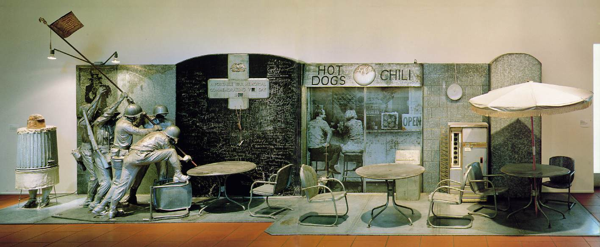

If we accept Webster’s most encompassing definition of politics as “the total complex of relations between people in a society,” then in some sense all art is political. That is to say, all art takes a stand—or is positioned by interpreters so that it does—in relation to the dominant values of its time. Since the 1960s, however, one might say that artists have become particularly conscious of the political resonances of their art. Amidst a general climate of social unrest and direct action, from the civil rights movements in the early sixties to the momentous events of 1968, the emphasis of many artists increasingly shifted from aesthetic to sociopolitical concerns. Rather than present a broad survey of this trend, this class will examine several of the most significant, self-conscious politics of artistic production from the 1960s to the present. Though a great deal of the class material will be presented in lecture format, discussion will be encouraged at all times. Although no previous art history experience is required, some familiarity and interest in contemporary art, history, politics, and/or critical theory is recommended.
Readings:
There is no required textbook. Class readings have been selected from many sources and may be purchased from The Ram Copy Center (4144 University Ave) as a course packet.
Student responsibilities:
Midterm Exam: 35%
Final Exam: 35%
2 Review Essays 20%
Active Participation 10% (Please note, active participation assumes that you thoroughly read
and think about course materials in advance of course meetings, and that you meaningfully contribute to discussions.)
Course Outline and Reading Assignments:

TH 9/27 Introduction to course; overview of major artists

T 10/2 Historical Precursors: Futurism, Dada, Social Realism
- Filippo Marinetti. “Founding Manifesto of Futurism,” in U. Appolinio, ed. Futurist Manifestos (NY: The Viking Press 1970): 19-24.
- Roselee Goldberg. “Futurism,” in Performance Art: from Futurism to the Present (NY: Abrams Publishers 1988): 11-30.
- Malcolm Green, “Preface,” Dada Almanac (London: Atlas Press 1993): i-xv.
- Optional: Richard Huelsenbeck. “Dadaist Manifesto,” in H. Richter ed., Dada: Art and Anti-Art (NY: Abrams Publishers 1966): 104-07.
- Optional: Lucy Lippard ed. “George Grosz and Wieland Herzfelde,” in Dadas on Art (NJ: Prentice-Hall 1971): 78-88.

TH 10/4-
T 10/9 Interrogating Boundaries: John Cage, Fluxus, Happenings and Pop
- Irving Sandler. “The Duchamp-Cage Aesthetic,” The New York School (NY: Harper and Row 1978): 163-71.
- Barbara Haskell. “Happenings,” Blam! The Explosion of Pop, Minimalism and Performance 1958-64 (NY: The Whitney Museum 1984): 31-48.
- Haskell. “Fluxus,” Blam!…(1984): 49-60.
- Excerpt from Art since 1900: Modernism, Antimodernism, Postmodernism, Vol. 2 (NY: Thames and Hudson 2004): 486-91.
- Optional: Sidra Stitch, “The Cultural Climate after World War II,” Made in the USA: An Americanization of Modern Art, the 50s & 60s (Berkeley: University of California 1987): 6-13.

TH 10/11 Installations of Discontent: Edward and Nancy Kienholz
- Walter Hopps. “A Note from the Underworld,” in Kienholz: A Retrospective (NY: The Whitney Museum 1996): 24-37.
- Excerpt from Art since 1900: Modernism, Antimodernism, Postmodernism, Vol. 2 (NY: Thames and Hudson 2004): 415-20.

T 10/16 The Stakes of the Ephemeral: Christo and Jean Claude
- Jonathan Fineberg, “On the way to the Gates,” in Christo and Jean Claude: On the Way to the Gates (2004): 3-55.

TH 10/18 Early Feminisms in the United States
- Norma Broude and Mary Garrard. “Introduction: Feminism and Art in the Twentieth Century,” in The Power of Feminist Art: The American Movement of the 1970s, History and Impact (NY: Abrams Publishers 1994): 10-29, 289-290.
- Lucy Lippard. “Setting a New Place: Judy Chicago’s Dinner Party,” in Get the Message: A Decade of Art for Social Change (New York: E.P. Dutton, Inc. 1984): 109-113.
- Arlene Raven, “Womanhouse,” in The Power of Feminist Art (1994): 48-65, 291.
- Amelia Jones, “The Sexual Politics of the Dinner Party: A Critical Context,” from Reclaiming Female Agency: Feminist Art History after Postmodernism (2005): 409-433.
- Optional: Gloria Feman Orenstein, “Recovering Her Story: Feminist Artists Reclaim the Great Goddess,” from The Power of Feminist Art (1994): 174-189.

T 10/23-
TH 10/25 Later Feminisms and discussion
- Jeff Kelley. “The Body Politics of Suzanne Lacy,” in But is It Art? The Spirit of Art as Activism (Seattle: Bay Press 1995): 221-49.
- Elizabeth Hess. “Guerilla Girl Power: Why the Art World Needs a Conscience,” in But is It Art? (1995): 309-332.
- Kate Linker, Love for Sale (excerpts) (NY: Abrams Publishers 1990): 12-18, 27-31, 59-64.
- Optional: Suzanne Lacy and Leslie Labowitz. “Feminist Media Strategies for Political Performance,” in Cultures in Contention, Kahn and Neumaier, eds. (Seattle: The Real Comet Press 1985): 122-133.
- Optional: Margaret Iversen. “Fashioning Feminine Identity,” Art International (Spring 1988): 52-57.
**Review Essay 1 due on Canvas 10/23

T 10/30 Catch up, Midterm review and discussion
Students required to submit 5 questions

TH 11/1 Midterm Exam in class: Take-home essay handed out (due 11/6)

T 11/6-
TH 11/8 Aspects of Black/African American Art in the U.S.
- Excerpt from Art since 1900: Modernism, Antimodernism, Postmodernism, Vol. 2 (NY: Thames and Hudson 2004): 639-44.
- Lowery Stokes Sims. “Aspects of Performance in the Work of Black American Women Artists,” in Feminist Art Criticism: An Anthology, Raven, Langer and Frueh, eds. (Ann Arbor: UMI Research Press 1988): 207-225.
- Optional: Yolanda Lopez and Moira Roth, “Social Protest: Racism and Sexism,” in The Power of Feminist Art (1994): 140-57, 293-294.
**Take-home essay due in class (11/6)

T 11/13-
TH 11/15 The Rise of Gay and Lesbian Artistic Practices: Lessons from the
Culture Wars.
- Richard Bolton et al, (excerpts) from Culture Wars: Documents from the Recent Controversies in the Arts (1992): 3-26 (Bolton), 27 (Wildmon), 33-36 (Gorton), 90-91 (Hughes), 201-204 (Lippard).
- Various newspaper articles: see packet.
- Excerpt from Art since 1900: Modernism, Antimodernism, Postmodernism, Vol. 2 (NY: Thames and Hudson 2004): 607-611.
- Richard Meyer, “Vanishing Points: Art, Aids, and the Problem of Visibility,” Outlaw Culture (2002): 225-275.
- Robert Atkins, “Goodbye Lesbian/Gay History, Hello Queer Sensibility,” Art Journal (Winter 1996): 80-85.

T 11/20 Cultural Shamanism, Radical Ecology and the Case of Joseph Beuys.
- Excerpt from Art since 1900: Modernism, Antimodernism, Postmodernism, Vol. 2 (NY: Thames and Hudson 2004): 480-85.
- Donald Kuspit. “Beuys: Fat, Felt and Alchemy,” Art in America (May 1980): 79-88.
- David Adams, “Joseph Beuys: Pioneer of Radical Ecology,” Art Journal (Summer 1992): 26-34.

TH 11/22 Thanksgiving Holiday: No Class

T 11/27-
TH 11/29 The Burden of History: Anselm Kiefer and Gerhard Richter
- Steven Madoff, “Anselm Kiefer: A Call to Memory,” Art News (October 1987): 125-30.
- Andreas Huyssen. “Anselm Kiefer: The Terror of History, the Temptation of Myth,” October (Spring 1989): 25-45.
- Jean Fisher. “The Tale of the German and the Jew,” Artforum (September 1985): 106-110.
- Optional: Lisa Saltzman, “Thou Shalt Not Make Graven Images: Adorno, Kiefer, and the Ethics of Representation,” in Anselm Kiefer and Art After Auschwitz (Cambridge: University Press 1999): 17-47.

T 12/4 Institutional Critique: Fred Wilson, Jimmy Durham, James Luna and Brian Jungen
- George Ciscle and Charles Lyle, “Forward” in Mining the Museum: An Installation by Fred Wilson (NY: The New Press 1994): lxxi-lxxii.
- Lisa Corrin, “Mining the Museum: Artists Look at Museums, Museums Look at Themselves,” in Mining the Museum… (1994): 1-22.
- Optional: Leslie King-Hammond and Fred Wilson, “A Conversation with Fred Wilson,” in Mining the Museum… (1994): 23-34 .
- Richard Shiff, “The Necessity of Jimmy Durham’s Jokes,” Art Journal (Fall 1992): 74-80.
- James Luna, “I’ve Always wanted to be an American Indian,” Art Journal (Fall 1992): 18-27.
- Jean Fisher, “In Search of the Inauthentic: Disturbing Signs in Recent Native American Art,” Art Journal (Fall 1992): 44-50.
- Peruse the work of Vancouver artist Brian Jungen: http://www.catrionajeffries.com
** Review Essay 2 Due on Canvas 12/4

TH 12/6 Northwest Artists Sampling

W 12/12 Take-home Final Exam Due on Canvas

Due dates:
10/23 Review Essay 1 Due
11/1: Midterm exam. Take-home handed out
11/6: Midterm take-home due
12/4: Review Essay 2 Due
12/12 Take-home Final Exam Due on Canvas

General sources:
Claire Bishop, Artificial Hells: Participatory Art and the Politics of Spectatorship (2012)
Claudia Mesch, Art and Politics (2013)
Linda Frye Burham, ed. The Citizen Artist: 20 Years of Art in the Public Arena (1998)
Thomas Crow. The Rise of the Sixties (1996).
Lucy Lippard. Mixed Blessings: New Art in Multicultural America (1990).
Lippard. Get the Message: A Decade of Art for Social Change (1984).
Toby Clark. Art and Propaganda in the Twentieth Century (1997).
Nina Felshin, ed. But is it Art: The Spirit of Art as Activism (1995).
Hal Foster et al., Art since 1900: Modernism, Antimodernism, Postmodernism, Vol. 2 (2004).

