Art History 203 (Writing Credit)

Survey of Western Art--Modern

Spring 2019

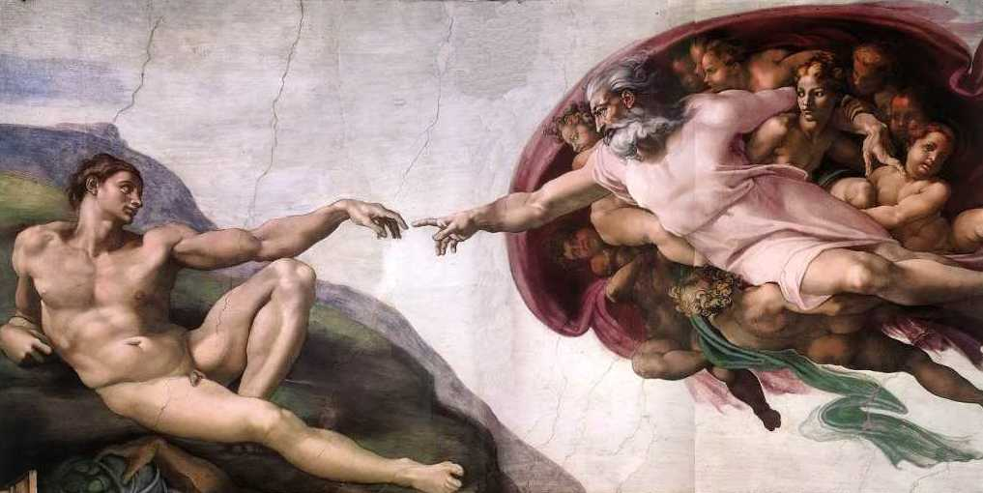
Instructor: Kolya Rice
Office hours: M/W 10-11 and by appointment
302 Art krice@uw.edu

Teaching Assistant: Hayley Watson
Office hours: Th 10-12 and by appointment
311 Art watsoh@uw.edu

Course Description:
This course introduces the major figures, styles and movements in Western art from the High Renaissance to the present. It also presents the principle issues, techniques, and interpretive methods of the discipline of art history. As well as learning to recognize the key “monuments” of European and American art from around 1500 to 1900, students will consider how a study of visual products adds to our understanding of past cultures and societies. Illustrated lectures anchor the course, but discussion is encouraged at all times, and sophisticated reading assignments will be provided to expand upon the text and lectures.

Required Readings:
- Textbook: Marilyn Stokstad, Art History, 6th Edition, vol. 2 (2018)
- Electronic Reserve Readings (ER) posted on Canvas
3. Lectures Guides (download from Canvas, print, and bring to class)

Helpful sources on 2hr reserve in Art library:
J. Pierce, From Abacus to Zeus: A Handbook of Art History.
J. Hall, Dictionary of Subjects and Symbols in Art.
S. Barnet, A Short Guide to Writing about Art.

To help you prepare for exams slides viewed in class during the week will be placed on Canvas, under the “files” tab. These slides will be accompanied with basic factual information (Artist, Title, Date).

Course Requirements:
- Active participation in all quiz sections and in-class exercises
Quiz sections are writing-focused unless otherwise specified. Students will gain skills in college-level art historical rhetoric and composition by workshopping specific fundamentals of academic writing. All students are expected to attend quiz section to contribute to and engage in discussions, group and partner exercises, in-class exercises, and peer reviews. Quiz sections are designed to improve the quality of your course papers and is a necessary component of gaining a “W” credit. Students are required to bring prepared materials to every quiz section unless otherwise noted. See the syllabus for the weekly breakdown of these required materials (RM). Failure to participate in quiz section and bring required materials will result in a weekly penalty to participation grade.
- 3-Page Compare/Contrast Formal analysis essay (See prompt on Canvas)
- 3-Page Summary Essay (See prompt on Canvas)
- 5-Page Directed Research paper (See prompt on Canvas)
- Midterm exam
- Final exam
Note: make-up exams will not be given without legitimate documentation of severe illness, family emergencies, etc. Extensions for written work will be granted only under similar conditions. Late papers will not be accepted. All course requirements must be completed for credit to be awarded.

Grading:
Midterm exam (25%)
Final exam (30%)
3-Page Compare/Contrast Essay (5%)
3-Page Summary Essay (5%)
5-Page Directed Research paper (20%)
Participation (15%)

Key dates to remember:
4/15: 1st draft Compare/Contrast Formal Analysis essay due on Canvas
4/19: Final draft Compare/Contrast Formal Analysis essay due on Canvas
4/28: 1st draft Summary Essay due on Canvas
5/3: Annotated bibliography due on Canvas
5/8: Midterm Exam in class
5/10: Final draft Summary Essay due on Canvas
5/13: Directed Research Paper thesis statement & outline due on Canvas
5/17: 1st draft of Directed Research Paper due on Canvas
6/5: Final draft of Directed Research Paper due on Canvas
6/11: Final Exam in class 8:30-10:20

Projected Course Outline and Reading Assignments
(Please have these assignments read by the date listed below.)

M 4/1 Introduction to Art History and the course
Stokstad: XVII-XXXVII

T 4/2 Intro to the course (small sections): Key art historical terminology and
“formal analysis”

W 4/3- LG #1: The High Renaissance: Leonardo and Raphael
M 4/8 Stokstad: 645-655
ER: H.W. Janson, History of Art (1995): #58, 59, 61, 66 (all readings
from H.W. Janson in one pdf but are individually numbered).

T 4/9 Formal analysis continued. Compare/Contrast Formal Analysis Essay
prompt discussion

W 4/10 LG #2: Michelangelo
Stokstad: 656-664, 685-689
ER: A. Blunt, “Michelangelo’s Views on Art,” from Readings in Art History II (1983): 103-124.
ER: H.W. Janson, History of Art (1995): #60, 62, 63, 64, 65, 67.

M 4/15 LG #3: Northern Italian Renaissance painting
Stokstad: 668-673
ER: J. Berger, Chapter 3 from Ways of Seeing (1972): 45-64.

T 4/16 Peer review of Compare/Contrast Formal Analysis essay.
RM: Bring a hard copy of your essay to section

W 4/17 LG #4: Mannerisms, 16th Century Venetian and Spanish painting
Stokstad: 673-675, 678-684, 709-710 (El Greco).
ER: H.W. Janson, History of Art (1995): #68.

M 4/22 LG #5 and #6: The Northern Renaissance
Stokstad: 691-702, 711-719
ER: H.W. Janson, History of Art (1995): #70, 71.
Optional ER: B. Scribner, “Ways of Seeing in the Age of Dürer,” from
Dürer and His Culture (1998): 93-117, 221-24.

T 4/23 Summary Essay Prompt and discussion. Intro to Directed Term Paper and
discussion

W 4/24 LG #7: Italian Baroque painting and sculpture
Stokstad: 725-741 (skim sections on architecture).
ER: H.W. Janson, History of Art (1995): #72.

M 4/29 LG #8: Baroque painting in France and Spain
Stokstad: 742-748, 769-778
ER: H.W. Janson, History of Art (1995): #76.

T 4/30 Directed Research Paper workshop: Prompt for Thesis/Outline and
discussion

W 5/1 LG #9: Baroque painting in Flanders and Holland
Stokstad: 749-768
ER: D. Mitchell, “Rembrandt’s The Anatomy Lesson of Dr. Tulp: a Sinner among the Righteous,” Artibus et Historiae (1994): 145-156.

M 5/6 LG #10: Rococo Painting

Stokstad: 922-929

T 5/7 Midterm review. Summary Essay initial feedback and peer review.
RM: Bring a hard copy of your Summary Essay to section.

W 5/8 Midterm Exam in class

M 5/13 LG #11: “The Grand Manner” in the U.S. and England
Stokstad: 929-945
ER: H.W. Janson, History of Art (1995): #81.

T 5/14 Directed research Paper workshop: Thesis and Outline
RM: Bring a hard copy of your thesis and outline to section.

W 5/15 LG #12: 19thC Representations of Native Americans and the West
Stokstad: None
ER: R. Hughes, excerpt from American Visions: The Epic History of Art in America (1997): 175-205.

M 5/20 LG #13: Neoclassicism and Romanticism in France and Italy
Stokstad: 952-956
ER: Eugène Delacroix, excerpts from his Journals (1822-24 & 32) from
Art in Theory: 1815-1900 (1998): 26-30 & 84-89.

T 5/21 Directed Research Paper workshop: Initial feedback and common
mistakes
RM: Bring a hard copy of the 1st draft of your Directed Research Paper to
section.

W 5/22 (Cont’d) LG #13: Neoclassicism and Romanticism in France and Italy

M 5/27 Memorial Day Holiday: No Class

T 5/28 No section meeting: Hayley will be available for individual and small group meetings during regular section hours.

W 5/29 LG #14: Romanticism in England, Germany and Spain
Stokstad: 956-974

M 6/3 LG #15: 19thC French Academicism, Naturalism and Realism
Stokstad: 980-993
ER: L. Nochlin, “Women Art and Power,” from Women Art and Power
and Other Essays (1988): 1-36.

T 6/4 Review for Final Exam

W 6/5 LG #16: Manet and Impressionism
Stokstad: 993-1010

Tuesday 6/11 Final Exam in class 8:30-10:20

VeriCite anti-plagairism software:
Notice: The University has a license agreement with VeriCite, an educational tool that helps prevent or identify plagiarism from Internet resources and work submitted by previous students of this course. I will use the service in this class; all assignments and quizzes you submit will be checked by VeriCite. The VeriCite Report will indicate the amount of original text in your work and whether all material that you quoted, paraphrased, summarized, or used from another source is appropriately referenced. All instances of intentional plagiarism will result in zero credit on the assignment, and a report of indicating academic dishonesty to the School of Art and the University of Washington. For further information, visit: https://itconnect.uw.edu/learn/tools/canvas/canvas-help-for-instructors/assignments-grading/vericite/plagiarism-faqs/

