AH 380a: Survey of 19th and 20th Century Western Art

Spring 2019

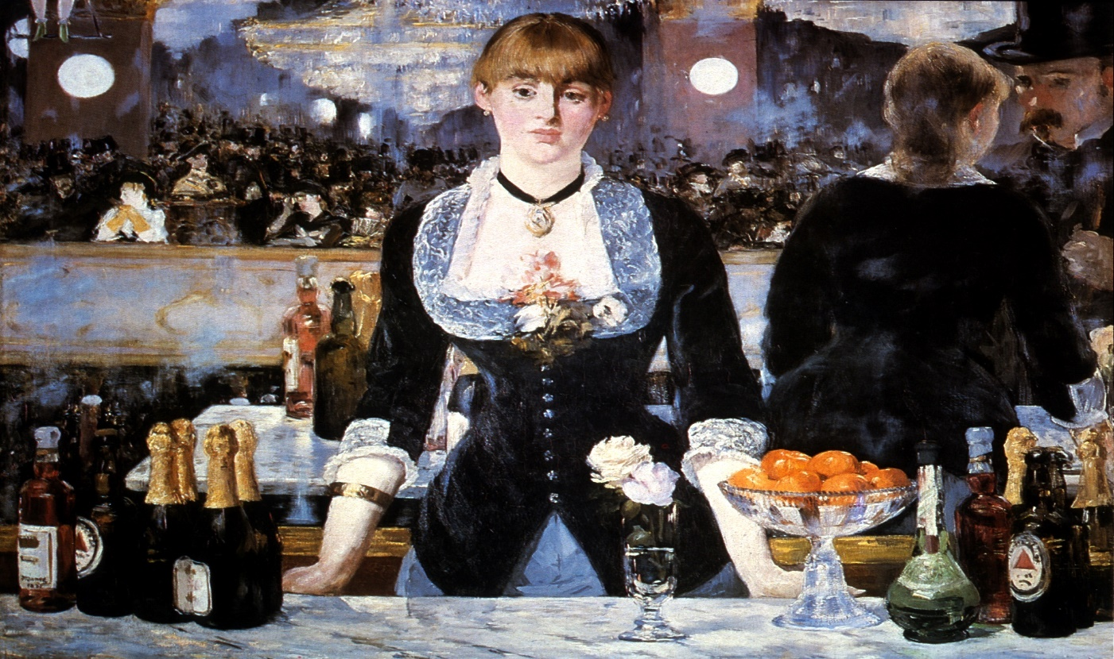

**Instructor:** Kolya Rice

Office/Hours: Art 302: M/W 10:30-11:20 and by appointment

[krice@uw.edu](mailto:krice@uw.edu)

This course surveys the major trends and key figures in Western painting, sculpture and alternative art forms from c.1780 to the present. Designed to impart to students a familiarity with the canonical works, styles and persistent themes in 19th and 20th century Western art, this course will emphasize understanding the art of this period as a product of its rich socio-cultural context. Further, this class will introduce some of the fundamental methods and strategies involved in Art Historical interpretations, so that students may continue to employ and develop their engagement with art and visual culture beyond the classroom environment. Although the class is anchored by lectures, numerous in-class discussions of rich reserve readings will punctuate the course.

Readings:

1. **TEXT**: H.H. Arnason and Marla F. Prather*, History of Modern Art: Painting,*

*Sculpture, Architecture, Photography*, 7th ed. (New Jersey: Prentice Hall: 2013).

1. **Reading Packet** (Purchase at RAM Copy Center, 4144 University Way)

To help you prepare for exams a selection of slides viewed in class during the week can be found as PDF files on Canvas, under the “files” tab.

**Course Requirements:**

1. **Active participation in all meetings.** Please note, active participation assumes that you thoroughly read and think about course materials in advance of class meetings, that you meaningfully contribute to discussions, and that you complete any informal exercises assigned.

2. **Midterm Exam**

3. **5 page interpretive essay**

4. **Final Exam**

Note: make-up exams will not be given without legitimate documentation of severe illness, family emergencies, etc. Extensions for written work will be granted only under similar conditions. Late papers will not be accepted. *All course requirements must be completed for credit to be awarded.*

**Grading:**

Midterm Exam (35%)

Final Exam (40%)

Interpretive essay (15%)

Active Participation (10%)

**Key dates to remember:**

5/3 Midterm Exam

6/7 Interpretive essay due

6/12 Final Exam 2:30-4:20

VeriCite disclaimer


**Course Outline and Reading Assignments**

(Please have these assignments read by the date listed below.)

**4/1 Introduction to the Course**

**4/3** **Introduction to Art History, Aesthetics and the Tradition of Classicism**

**Handout**: Excerpts from Poussin and Reynolds on Academic aesthetics

**Text**: Chapter 1

**4/5 Neoclassicism and Grand Manner Painting and Sculpture**

**Packet: •**Canaday, “Revolution,” *Mainstreams of Modern Art* (1981): 3-23

**4/8- From Ingres to Romanticism: Framing the Female Nude/Body**

**4/10 Packet:**  **•**Canaday, “The Flowering of Romanticism,”*Mainstreams of Modern Art*

(1981): 52-65

**•**Canaday, “Delacroix,”*Mainstreams of Modern Art* (1981): 66-75

**•**Berger, “Chapter 3,” *Ways of Seeing* (1972): 45-64

**•**Nochlin, “Women, Art and Power,” *Women, Art and Power and other Essays*

(1988): 1-36

**4/12-** **Representing 19thC America: The Landscape, the West, and the Other**

**4/15 Packet: •**Hughes, excerpts from “The Wilderness and the West,” *American Visions*

(1997): 137-151, 157-167, 175-205

**Optional:** Truettner, William, “Ideology and Image: Justifying Westward

Expansion,” The West as America: Reinterpreting Images of the American Frontier (1991): 27-51

**4/17 Naturalism and Realism**

**Text:**  Chapter 2

**Packet: •** Eisenman, “The Rhetoric of Realism: Courbet and the Origins of the Avant-

Garde,” *Nineteenth-Century Art: A Critical Anthology* (1992): 238-54

**4/19- Manet and Impressionism**

**4/22 Packet: •**Eisenman, “Manet and the Impressionists,” *Nineteenth-Century Art: A*

*Critical Anthology* (1992): 238-54

**•**Shiff, “Defining ‘Impressionism’ and the ‘Impression,’*” Art in Modern Culture: An Anthology of Critical Texts* (1992): 181-88

**Optional:** Clark, “Introduction,” from *Painting of Modern Life* (1985): 2-22

**4/24 The Rise of Modern Art in England: The Pre-Raphaelite Brotherhood and Whistler**

**Packet**: **•** Canaday, “Romatic Revolt in England: The Pre-Raphaelites,” *Mainstreams*

*of Modern Art* (1981): 90-103

**4/26- Post-Impressionism**

**4/29 Text:** Chapter 3

**Packet: •**Van Gogh, “Excerpts from the Letters,” from *Theories of Modern Art* (1968): 29-47

**5/1 Catch-up, discussion and Midterm review. Each student must bring 3 questions to class**

**5/3 Midterm Exam in class**

**5/6 No Class**

**5/8- Fauvism and Expressionism**

**5/10 Text:** Chapters 7, 8

**Packet: •**Kandinsky, “The Effect of Color,” from *Theories of Modern Art* (1968): 152-

55

**Optional:** Kandinsky, “The Problem of Form,” from *Theories of Modern Art* (1968): 155-70

**Optional:** Duncan, “The Aesthetics of Power in Modern Erotic Art*,” Feminist Art Criticism: An Anthology* (1988): 59-69

**5/13 Cubism and Its Legacies**

**Text:** Chapter 10

**Packet: •**Bell, “The Aesthetic Hypothesis,” from *Modern Art and Modernism: A*

*Critical Anthology* (1982): 67-74

**5/15- The Historical Avant-Garde: Futurism, Dada and Duchamp**

**5/17 Text:** Chapters 11, 13

**Packet: •**Marinetti, “The Founding Manifesto of Futurism,” from *Art in Theory 1900-2000: An Anthology of Changing Ideas* (2003): 146-149

**5/20 Surrealism**

**Text:** Chapter 15

**Packet: •**Breton, “First Manifesto of Surrealism,” from *Art in Theory 1900-2000: An*

*Anthology of Changing Ideas* (2003): 447-453

**Optional:** Freud, “On Dreams,” from *Art in Theory 1900-2000* (2003): 21-28.

**5/22 Early 20th Century American Painting**

**Text:**  Chapter 18

**Packet: •**Davis, “On Abstract Art,” from *Abstract Painting in America* (1935): 122-23

**5/24 Abstract Expressionism: Artists and Critics**

**Text:** Chapter 19

**Packet: •**Greenberg, “Modernist Painting,” *The New Art* (1966): 100-110.

**Optional:** Greenberg, “Avant-Garde and Kitsch,” *from Clement Greenberg: The Collected Essays*, vol. I (1986): 5-22

**5/27 Memorial Day Holiday: No Class**

**5/29 Abstract Expressionism: Artists and Critics (cont’d)**

**5/31- Reactions to Abstract Expressionism**

**6/3 Text:** Chapters 21 and 22 (focus on Post-Painterly Abstraction).

**Packet: •**Sandler, “The Duchamp-Cage Aesthetic,” *The New York School* (1978): 163-173

**6/5 Feminist Art Practices**

**Text:** Skim chapters 24 & 25.

**Packet: •**Broude and Garrard, “Introduction: Feminist Art in the Twentieth Century,” *The Power of Feminist Art* (1994): 10-29

**6/7 Review for Final. Each student must bring 3 questions to class.**

**\*\*Interpretive essays due in class and upload to Canvas**

**6/12 Final Exam 2:30-4:20**