Art History 270
Art/Identity/Politics: Issues of Representation in Contemporary Art
Summer Quarter 2018
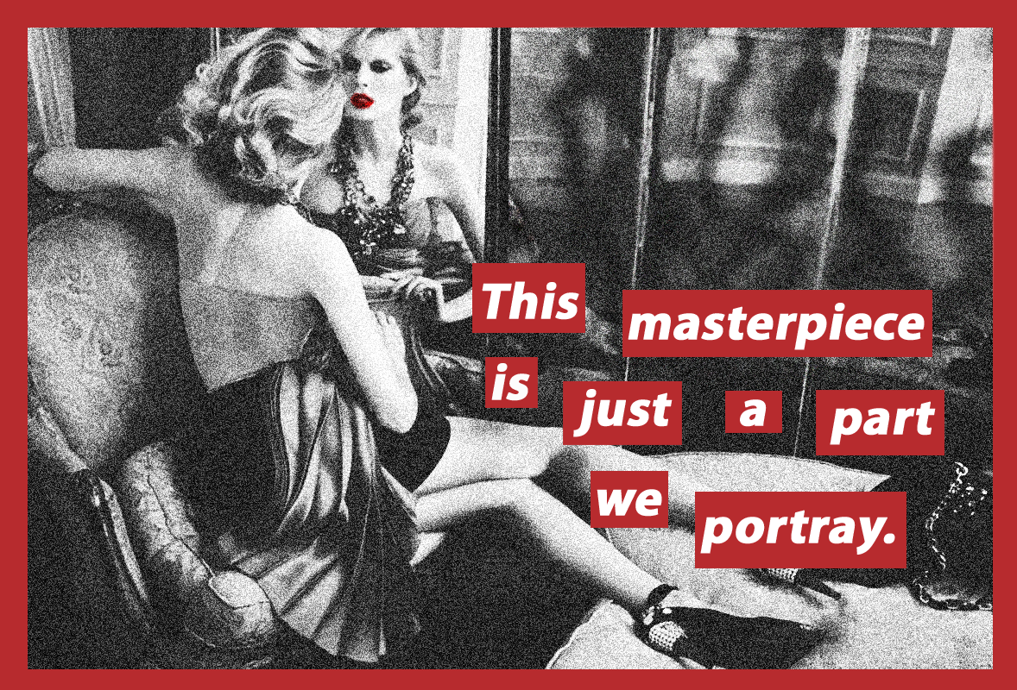
Instructor: Kolya Rice
krice@uw.edu
Office hours: m/w 9:30-10:30 by appointment: Art Bldg 302

Course Description:
This course is designed to introduce participants to various ways contemporary artists and art movements, primarily in the U.S., have explored the intersection of visual representation, identity (gender, ethnic, racial, sexual) and politics, one of the most persistent themes in art since the 1960s. Participants will work through sequences of materials and assignments organized in weekly “modules” on Canvas according to their own individual schedules with a great degree of flexibility. In the few cases where there is a fixed time that students will need to adhere to, multiple time slots will be offered so that everyone will be able to participate as fits their schedule.
Course content will be delivered through a series of Panopto video lectures and coordinated readings where participants will explore how artists have contested dominant representations of gender, sexuality, race, ethnicity, as well as other minority “subjectivities,” and how artists have proposed alternatives for the representation of these constituencies. Online discussion forums, reflective papers on readings, online quizzes and assignments have been designed to engage students with course topics, foster creative and critical thinking, allow dialogue concerning the stakes involved in visual representations, and allow instructor assessment and evaluation of participants’ progress.
Required Readings:
There is no text for this course. Pdf files of course readings are posted on Canvas. Each weekly “module” on Canvas contains the course readings for that week. For most readings, I will provide an introduction and “reading guides” that will help you focus on and engage with key ideas.
Student Responsibilities:
3 quizzes: 15% each (45% of overall grade)
Each quiz will require students to write short answers and longer essays on topics covered in the Panopto lectures and readings. These are open notes quizzes—you may return to the lectures and readings when composing your answers. Each quiz will only cover the topics for that 3 week section of the course. In other words, they are not comprehensive. These quizzes will be graded on a 100 point scale.
Summary/reflective essays on reading assignments (35%)
To ensure that participants have on strong comprehension of key ideas from course readings, and to allow me to offer feedback, each week students will write summary/reflective essays on the readings. I will provide you with two “guides” to help you compose these informal essays. First, you will get a specific, if general prompt for each weekly summary/reflective reading. Second, you can refer to the reading guides, or even answer the questions provided in them for that week as you compose your essays. These essays will be graded on a 10 point scale.
Participation in weekly discussion forums (20%)
The topics of this course lend themselves to rich discussion and manifold perspectives. Candidly, this is often difficult to achieve in an online course. My hope is that you will engage with each other, respectfully and thoughtfully in the weekly online discussion forums. Each week I will provide you with specific topics, ideas and issues raised in the lectures and reading. Each student will be required to make one post in the discussion forum before the end of the day on Wednesdays. Once you have posted, you will be able to see others students’ posts. You are required to respond to at least one of these posts from another student by the end of the day on Fridays. You are welcome and encouraged to post/respond as many times as you desire. Your posts/responses will be graded on a 10 point scale.

VeriCite anti-plagairism software:
Notice: The University has a license agreement with VeriCite, an educational tool that helps prevent or identify plagiarism from Internet resources and work submitted by previous students of this course. I will use the service in this class; all assignments and quizzes you submit will be checked by VeriCite. The VeriCite Report will indicate the amount of original text in your work and whether all material that you quoted, paraphrased, summarized, or used from another source is appropriately referenced. All instances of intentional plagiarism will result in zero credit on the assignment, and a report of indicating academic dishonesty to the School of Art and the University of Washington. For further information, visit: https://itconnect.uw.edu/learn/tools/canvas/canvas-help-for-instructors/assignments-grading/vericite/plagiarism-faqs/

Course Outline and Schedule:
(Specific prompts for the assignments listed below will be found on Canvas.)

Week 1: Introduction: Setting the stage:
Module 1: Introduction to the course: overview
Assignments:
1. Panopto video lecture
2. Discussion forum—write a brief personal bio and reflection on your sense of your own identity and post. See prompt on Canvas.

Module 2: Problems in the Field of Representation: overview of how “woman” and “femininity” have been represented historically in western culture.

Assignments:
1. Panopto video lecture
2. Reading summary and reflection

Readings:
▪Brian Wallis (excerpt) “What Wrong with this Picture: An Introduction,” from Art after Modernism: Rethinking Representation (1984): xi-xvi.
▪John Berger, Chapter 3 from Ways of Seeing (1972): 45-64.
▪Jean Robertson and Craig McDaniel, “Identity” in Themes of Contemporary Art (2013): 40-76.
▪Key terms from David Macey, The Penguin Dictionary of Critical Theory
(2000): Browse this, and use it as needed throughout the quarter.

Optional reading:
▪David Summers, “Representation” from Critical Terms for Art History (1996): 3-16.

Week 2: First Generation Feminist Arts in the United States:
Module 3: “First Generation” Feminist Arts in the United States: strategic essentialism
Assignments:
1. Panopto video lectures
2. Discussion forum
3. Reading summary and reflection

Readings:
▪Norma Broude and Mary Garrard, “Introduction: Feminism and Art in the
Twentieth Century,” from The Power of Feminist Art (1994): 10-29.
▪Rebecca Schneider, “Eye/Body: Carolee Schneemann
beside Herself,” The Explicit Body in Performance (1997): 32-42.
▪Gloria Feman Orenstein, “Recovering Her Story: Feminist Artists Reclaim the Great Goddess,” from The Power of Feminist Art (1994):
174-189

Optional Readings:
▪Claudia Mesch, “Feminisms,” from Art and Politics (2013): 99-124.
▪Simone de Beavoir, (excerpt) The Second Sex (1949): xv-xviii.
▪ Judith Butler, “Gendering the Body: Beauvoir’s Philosophical Contribution,” from Women, Knowledge and Reality: Explorations in Feminist Philosophy (1989): 253-262.
▪Betty Friedan, The Feminine Mystique (excerpt) (1963): 62-72

Week 3: First Generation Feminist Arts in the United States
Module 4: Case Study: West Coast Feminist Arts: Herstory and “visibility”
Assignments:
1. Panopto video lectures
2. Discussion forum
3. Reading summary and reflection

Readings:
▪Arlene Raven, “Womanhouse,” from The Power of Feminist Art (1994):
48-63.
▪Lucy Lippard, “Setting a New Place: Judy Chicago’s Dinner Party,”
(1974), Get the Message: A Decade of Art for Social Change (1984):
109-113.
▪Jeff Kelley. “The Body Politics of Suzanne Lacy,” But is It Art? The Spirit of Art as Activism (Seattle: Bay Press 1995): 221-49.
▪Elizabeth Hess. “Guerilla Girl Power: Why the Art World Needs a Conscience,” in But is It Art? (1995): 309-332.

Optional Reading:
▪Amelia Jones, “The Sexual Politics of the Dinner
Party: A Critical Context,” from Reclaiming Female Agency: Feminist
Art History after Postmodernism (2005): 409-433.

Week 4: Second Generation Feminists Arts: “decentered subjectivity”
Module 5:
Assignments:
1. Panopto video lectures
2. Discussion forum

Readings:
▪Hal Foster, et al., Art Since 1900: Modernism, Anti-modernism,
Postmodernism, v. II (2004): 580-583.
▪Margaret Iversen, “Fashioning Feminine Identity,” Art International
(Spring 1988): 52-57.
▪Kate Linker, (excerpt) Love for Sale: The Words and
Pictures of Barbara Kruger (1990): 12-18, 27-30, 59-64.

Optional Reading:
▪Kate Linker, “Representation and Sexuality,” from Art after Modernism: Rethinking Representation (1984): 391-415.

Week 5: Recap, preparation for quiz 1, and discussion
Module 6:
Assignments:
1. Panopto video lecture
2. Discussion forum
3. Quiz 1

Week 6: Representing Race:
Module 7 Black/African American U.S. Women Artists and Feminism

Assignments:
1. Panopto video lectures
2. Discussion forum
3. Reading summary and reflection

Readings:
▪Hal Foster et. al., Art since 1900: Modernism, Antimodernism, Postmodernism, Vol. 2 (2004): 639-44.
▪bell hooks, “Marginality as Site of Resistance,” from Out There:
Marginalization and Contemporary Cultures (1990): 341-43.
▪Adrian Piper, “The Triple Negation of Colored Women Artists,” from
The Feminism and Visual Culture Reader (2003): 239-248

Optional Readings:
▪Yolanda Lopez and Moira Roth, “Social Protest: Racism and Sexism,”
from The Power of Feminist Art (1994): 140-57, 293-94.
▪ Lowery Stokes Sims, “Aspects of Performance in the Work of Black American Woman Artists,” from Feminist Art Criticism: An Anthology (1988): 207-225.
▪Claudia Mesch, “Postcolonial Identity and the Civil Rights Movement,” from Art and Politics (2013): 44-67.

Week 7: Black/African American U.S. Male Artists:
Module 8
Assignments:
1. Panopto video lectures
2. Discussion forum
3. Quiz 2

Readings:
▪Claudia Mesch, “Postcolonial Identity and the Civil Rights Movement,” from Art and Politics (2013): 44-67.
▪Hal Foster, et al. (excerpt) Art since 1900 (2004): 639-644.
▪Thelma Golden, “My Brother,” from Black Male Representations of Masculinity in Contemporary American Art (1994): 19-43.

Optional Reading:
▪bell hooks, “Feminism Inside: Toward a Black Body Politic,” from Black Male Representations of Masculinity in Contemporary American Art (1994): 127-139.

Week 8: GLBTQ Arts
Module 9 Assignments:
1. Panopto video lectures
2. Discussion forum

Readings:
▪Anne D’Alleva, “Sexualities, LGBTI Studies and Queer Theory” Look
Again: Art History and Critical Theory (2005):70-74.
▪ Claudia Mesch, “Gay Identity/Queer Art” from Art and Politics (2013): 125-147.
▪Hal Foster, et al. from Art since 1900 (2004): 607-611.
▪Richard Meyer, “Vanishing Points: Art, Aids, and the Problem of
Visibility,” Outlaw Culture (2002): 225-275.

Optional Readings:
▪Douglas Crimp, “Mourning and Militancy,” from Out There: Marginalization and Contemporary Cultures (1990): 233-245.
▪Robert Atkins, “Goodbye Lesbian/Gay History, Hello Queer Sensibility,”
Art Journal (Winter 1996): 80-85.

Week 9: Contemporary American Indian Arts and Postcolonialism
Module 10
Assignments:
1. Panopto video lectures
2. Discussion forum
3. Discussion forum reflection on personal “identity”
4. Quiz 3

Readings:
▪Anne D’Alleva, “Cultural Studies and Postcolonial Theory,” Look Again (2005): 76-81.
▪Lisa Corrin, “Mining the Museum: Artists Look at Museums, Museums
Look at Themselves, Mining the Museum (1994): 1-22.
▪Jean Fisher, “In Search of the Inauthentic: Disturbing Signs in Recent Native American Art,” Art Journal (Fall 1992): 44-50.
▪Richard Shiff. “The Necessity of Jimmy Durham’s Jokes,” Art Journal
(Fall 1992): 18-27.
▪James Luna. “”I’ve Always Wanted To Be an American Indian,” Art Journal (Fall 1992): 44-50.

