Autumn 2019

AH 309C: 20th Century American Art and Criticism
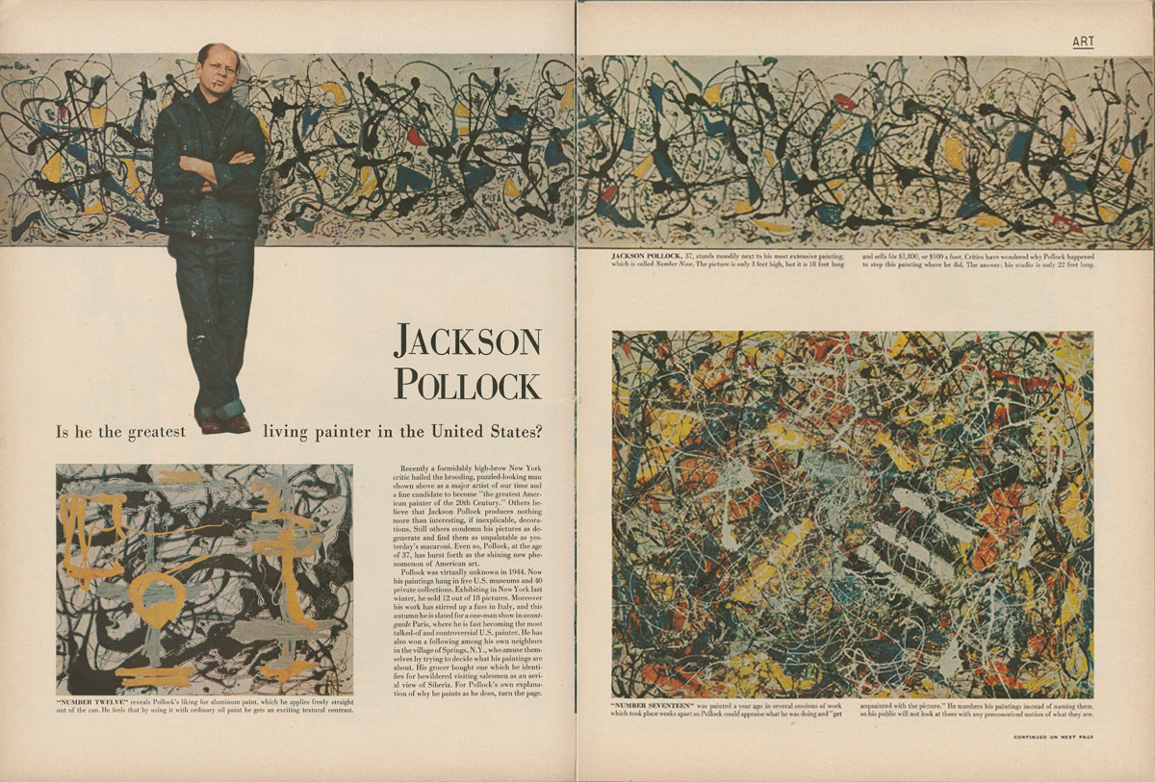
Instructor: Kolya Rice
Office hours: M/W 10-11 and by appointment
302 Art, krice@uw.edu

Description:
This course is designed to introduce participants to key movements, themes and strategies utilized by artists practicing in the United States from around 1900 to 1990. Unlike traditional surveys, the course will focus on how these artistic practices have been framed by influential art writing, both professional art criticism as well as the artists' own writings. Although the course offers an overview of the period covered, unlike traditional survey classes, at points this class will be more narrowly focused through topical investigations of specific artists or themes. While image-based lectures anchor the course, discussion is integral to the success of the course.

Readings:
- TEXT: H.H. Arnason and Marla F. Prather, History of Modern Art: Painting,
Sculpture, Architecture, Photography, 7th ed. (New Jersey: Prentice Hall: 2013).
- Reading Packet (Purchase at RAM Copy Center, 4144 University Ave)

To help you prepare for exams, a selection of images viewed in class during the week will be placed on Canvas as pdf files. These images will be accompanied with basic information (Artist, Title, Date). These may be found under the “Files” tab on Canvas.

Course Requirements:
1. Active participation in all meetings. Please note, active participation assumes that you thoroughly read and think about course materials in advance of class meetings, that you meaningfully contribute to discussions, and that you complete any informal exercises assigned.
2. Midterm Exam
3. 2 Art Review Essays
4. Final Exam
Note: make-up exams will not be given without legitimate documentation of severe illness, family emergencies, etc. Extensions for written work will be granted only under similar conditions. Late papers will not be accepted. All course requirements must be completed for credit to be awarded.

Grading:
Midterm Exam (35%)
Final Exam (35%)
2 Art Review Essays (20%)
Participation (10%)

Key dates to remember:
10/21 Review #1 due in class
10/25 Midterm take-home component handed out
10/28 Midterm Exam in class component
11/8 Midterm take-home due in class
12/6 Review #2 due in class
12/9 Final Exam 8:30-10:20

VeriCite anti-plagairism software:
Notice: The University has a license agreement with VeriCite, an educational tool that helps prevent or identify plagiarism from Internet resources and work submitted by previous students of this course. I will use the service in this class; all assignments and quizzes you submit will be checked by VeriCite. The VeriCite Report will indicate the amount of original text in your work and whether all material that you quoted, paraphrased, summarized, or used from another source is appropriately referenced. All instances of intentional plagiarism will result in zero credit on the assignment, and a report of indicating academic dishonesty to the School of Art and the University of Washington. For further information, visit: https://itconnect.uw.edu/learn/tools/canvas/canvas-help-for-instructors/assignments-grading/vericite/plagiarism-faqs/

Projected Course Outline and Reading Assignments

(Please have these assignments read by the date listed below.)

W 9/25 Introduction to the Course

F 9/27 Cultural Backdrop: The Rise of Abstraction in Europe
Text: Chapters 5-6
Packet:
•Kerr Houston, “Introduction” An Introduction to Art Criticism (NY: Pearson), 2013, pp. 1-22.
•Kandinsky, “The Effect of Color,” from Theories of Modern Art (1968): 152-
55.
Optional: Kandinsky, “The Problem of Form,” from Theories of Modern Art (1968): 155-70.

M 9/30 The Rise of Abstraction in Europe and Formalist Art Criticism
Text: Chapter 7 & 11 and pp. 257-58 (focus on Picasso, Braque and later Matisse).
Packet:
•Picasso, “Picasso Speaks” (1923) in Art in Theory 1900-2000 (2003): 215-217.
•Bell, “The Aesthetic Hypothesis,” from Modern Art and Modernism: A
Critical Anthology (1982): 67-74.

W 10/2 Formalist Art Criticism
•Kerr Houston, “A History of Art Criticism,” excerpt from An Introduction to Art Criticism (NY: Pearson), 2013, pp. 39-55
• Roger Fry, “The French Post-Impressionists,” from Modern Art and Modernism, Francis Frascina and Charles Harrison, eds (New York: Harper and Row), 1982, pp. 89-91 (Essay first published in 1912)
• Clive Bell, "The Aesthetic Hypothesis," (1914) from Modern Art and Modernism, pp. 67-78
• Clive Bell, “The Debt to Cezanne,” (1914) from Modern Art and Modernism, pp. 75-78

F 10/4- Early 20thC American painting
M 10/7 Text: Chapter 15
Packet:
•Robert Henri, excerpt from The Art Spirit (Philadelphia and New York: J. B. Lippincott), 1960, pp. 116-17, 188-89
•Kenyon Cox, Chapter one, Artist and Public (London: George Allen and Unwin Ltd.), 1914, pp.1-43
•Davis, “On Abstract Art,” from Abstract Painting in America (1935): 122-23.

W 10/9 Marxist Criticism: Meyer Schapiro
Packet:
• Meyer Schapiro, "The Social Bases of Art," (1935) from Matthew Baigell and Julia Williams, eds., Artists Against War and Fascism: Papers of the First American Artists Congress (New Brunswick, N.J.: Rutgers University Press), 1986, pp.103-113
•Meyer Schapiro, “The Nature of Abstract Art,” originally published in Marxist Quarterly, 1937

F 10/11- Regionalism, Social Realism and Populism/Nationalism as Critical Agendas
M 10/14 Text: Chapter 15
Packet:
• Thomas Craven, "Modernism," Men of Art (New York: Simon and Schuster), l933, pp. 491-513
• Thomas Hart Benton, excerpt from An Artist in America (1951), pp. 314-319
• OPTIONAL: Diego Rivera, "The Revolutionary Spirit in Modern Art," from David Shapiro, Social Realism: Art as Weapon (New York: Frederick Ungar), l973, pp. 54-75 (This essay originally appeared in Modern Quarterly, vol. 6, no. 3, Autumn l932)
• OPTIONAL: Ben Shahn, “The Artist and the Politician” (1953) reprinted in Art in Theory 1900-2000 (2003): 674-677

W 10/16 Abstract Expressionism: Artists
Text: Chapter 16

F 10/18 Abstract Expressionism: Critics: Harold Rosenberg and “Action Painting”
•Kerr Houston, “A History of Art Criticism,” excerpt from An Introduction to Art Criticism (NY: Pearson), 2013, pp. 55-63
• Harold Rosenberg, "The American Action Painters," Art News, Dec. l952, pp. 22-23, 48-50
•Harold Rosenberg, "Action Painting: Crisis and Distortion," The Anxious Object (New York: Horizon Press), l964, pp. 39-47

M 10/21- Clement Greenberg: The Apex of Formalist Criticism
W 10/23 • Clement Greenberg, "How Art Writing Earns a Bad Name," Encounter (Dec., l962), pp. 67-71
• Clement Greenberg, "Modernist Painting" from Gregory Battcock, ed., The New Art (New York, E.P. Dutton), l966, p.101-110
• Clement Greenberg, "Post-Painterly Abstraction,” Art International, Summer, l964, pp. 63-64 (This magazine article reproduces Greenberg's catalogue essay for the "Post-Painterly Abstraction" exhibition mounted by the Los Angeles County Museum of Art in l964)
• Clement Greenberg, "Complaints of an Art Critic," Artforum, Oct., l972, pp. 38-39
• Clement Greenberg, "The Necessity of Formalism," The Lugano Review, Oct., l972, pp. 105-106
• OPTIONAL: Clement Greenberg, “Avant-Garde and Kitsch,” (1939) reprinted in Clement Greenberg: The Collected Essays, vol. I (1986): 5-22
**Art Review 1 Due on Canvas 10/21

F 10/25 Catch-up and review for Midterm Exam. Each student must bring 3 written questions to class. Midterm Take-Home Essay handed out in class.

M 10/28 Midterm Exam in class

W 10/30- Reactions to Abstract Expressionism
F 11/1 Text: Chapters 19 (pp. 486-504) and 20 (focus on Post-Painterly Abstraction).
Packet:
•Kerr Houston, “A History of Art Criticism,” excerpt from An Introduction to Art Criticism (NY: Pearson), 2013, pp. 63-69.
•Sandler, “The Duchamp-Cage Aesthetic,” The New York School (1978): 163-173.
•Duchamp, “The Creative Act,” in Battcock ed., The New Art (1966): 23-26.
•OPTIONAL: Michael Fried, “Art and Objecthood” (Artforum, June 1967):
•Robert Morris, “Notes on Sculpture 1 & 2,” (1966) in Continuous Project Altered
Daily: The Writings of Robert Morris (1993): 1-21.

M 11/4- Early Performance Art
W 11/6 Text: Chapter 18 and 19
Packet:
•Barbara Haskell. “Happenings,” Blam! The Explosion of Pop, Minimalism and Performance 1958-64 (NY: The Whitney Museum 1984): 31-48.

F 11/8 Pop Art
Text: Chapter 19
Packet:
• Lawrence Alloway, “The Arts and the Mass Media,” (1958) from Art in Theory 1900-2000 (MA: Blackwell), 2003, pp. 715-717
**Midterm take-home due on Canvas

M 11/11 Veterans Day: No Class

W 11/13- Feminist Art Practices in the United States part 1
F 11/15 Text: Skim chapter 22
Packet:
•Broude and Garrard, “Introduction: Feminist Art in the Twentieth Century,” The
Power of Feminist Art (1994): 10-29.
• Lucy Lippard, “Sexual Politics, Art Style,” (1971) from Artists, Critics, Context: Readings in and around American Art since 1945 (NJ: Prentice Hall), 2002, pp. 339-343
• Lucy Lippard, “The Women Artists’ Movement—What Next?” (1975) reprinted in An Introduction to Art Criticism (2013): 290-292.

M 11/18 Feminist Art Practices in the United States part 2
Packet:
•Kate Linker, excerpts from Love for Sale (NY: Abrams 1990): 12-18, 27-31, 59-64.

W 11/20- Sculpture in an Expanded Field: Light Art and Earthworks
F 11/22 Text: Chapter 23

Packet:

•Patricia Failing. “James Turrell’s New Light on the Universe, Art News (April 1985): 71-78.
•Optional: Rosalind Krauss, “Sculpture in the Expanded Field,” October (Spring
1979): 30-44

M 11/25 Guest Lecture: TBA

W 11/27- Extended Thanksgiving Break: No Class
F 11/29

M 12/2- Art and the Politics of Identity
W 12/4 Text: Chapters 26-27
Packet:
•Lisa Corrin, “Mining the Museum: Artists Look at Museums, Museums Look at Themselves, Mining the Museum (1994): 1-22.
•Richard Shiff. “The Necessity of Jimmy Durham’s Jokes,” Art Journal (Fall 1992): 18-27.
•James Luna. “I’ve Always Wanted To Be an American Indian,” Art Journal (Fall 1992): 44-50.

F 12/6 Catch-up and review for Final Exam. Each student must bring 3 written questions to class.
Packet:
•James Elkins, excerpt from What Happened to Art Criticism? (2003) excerpt reprinted in An Introduction to Art Criticism (2013): 302-309.
**Art Review 2 Due on Canvas

M 12/9 Final Exam in class 8:30-10:20
Writing Assignment: Review Articles

Over the course of the quarter each student or team (up to 3 students) will be responsible for reviewing 2 gallery or museum shows in the Seattle area. Each review should be approximately 3-5 pages in length, and may be made available to other students in the class in some form.

I want this component of the class to be very open to your own interests, and so I’ll keep the guidelines basic, and you can see me if you want a greater degree of direction. First, the goals of this component are: (1) To prod you into confronting contemporary art face-to-face; (2) to have you discuss your ideas with a small group of your peers; (3) to face the difficult task of translating your experience of the art into written words; (4) to assess the significance of art, and reflect upon the qualities you (and your peers) value in art. Without exception, you should engage with the exhibition in a personal, self-reflexive manner. This should be clear in the review. However, always remember that you are writing for someone else, readers, and these reviews should be useful to them.

Picking shows. I will be happy to help you find artists/shows that might interest you, but you have to start the process. Look through the papers, or on the web to see what’s out there: I’ve listed useful sites below. Or, browse the galleries on the “First Thursday” of the month (“Gallery Walk”). Also, I’ve listed below a number of places I think have consistently strong exhibitions.

Once you’ve decided on the artist/show you want to review, spend some time with your group in front of the works talking about them. (If you’re reviewing a group show, find one or two works/artists that really interest you and focus on them.) Discuss in particular: (1) what the works seem to be about, the issues they raise and the stances they take; (2) how they might be related to ideas/issues/works we’ve encountered in class; 3) how successful you feel the works are and why. You may look at reviews by local critics, and I’ll give you samples of students’ reviews from past classes, but please do not use their approaches as strict templates for your own. And do not, under any circumstances, “forget” to cite any sources you use; this includes gallery websites, press releases, etc.

Review deadlines. To space out the reviews over the course of the quarter, here are the deadlines for each review. You may write them any time before these dates:
10/21, 12/6

Format: 3-5 pages, double-spaced, 1” margins, Word documents or PDF files (make sure your files are saved with .doc or .pdf at the end; this will ensure that I can open them).

Please upload to Canvas

Review Essay Checklist:
Head your essay with:
- Gallery/Museum or Sites name, address, contact information, hours.
- The show’s title, running dates, and key artists you’ll cover
- The names of the members of your team, if you’re collaborating.

Introduction: Give your readers an overview of the show, describing the visual experience, alerting them to the key issues/ideas the artist(s) is exploring or that you will be addressing.
Body: Pick no more than three works that will serve as examples of the keys points you want to make about the show.
- What theme or idea is the work exploring in general? Do different works take different stances, or explore different facets of the general theme?
- Can you relate works in the exhibition to works you’ve seen before? Works from class? Politics? Philosophy? Visual culture at large? What’s similar or different?
- If you have access to an artist’s statement, does that help you to understand the work more fully? Does it detract from other possibilities of interpretation?
- What materials are being used? For what reason, or to what effect? Do the materials have particular historical or cultural resonance?
- Do you find the works compelling? If so, in what way (be specific)? If not, why not? Remember here, it is easy to admire an artist’s subject in advance—and forget about how that subject is represented or indeed whether an artist has made you think about the subject in a new way.
Conclusion: You’ll probably want to summarize key points in the body, of course, but consider the conclusion as a way to ask questions the work made you think about, but which are better left as the subject of a longer analysis. You should also bring together your assessment of the show here, summarizing who might be interested in the show, and why—or why not (drawing from your refection on your own experience).

Useful electronic sources to get you started:
www.seattleweekly.com
www.thestranger.com

Some (usually) interesting galleries:
The Seattle Art Museum: http://www.seattleartmuseum.org
The Henry (at the UW): www.henryart.org
The Frye (710 Terry): www.fryeart.org
Greg Kucera (212 3rd Ave): www.gregkucera.com
James Harris Gallery (604 2nd Ave): https://jamesharrisgallery.com/
Soil Gallery (112 3rd Ave S): http://soilart.org/

