ENGL 200A
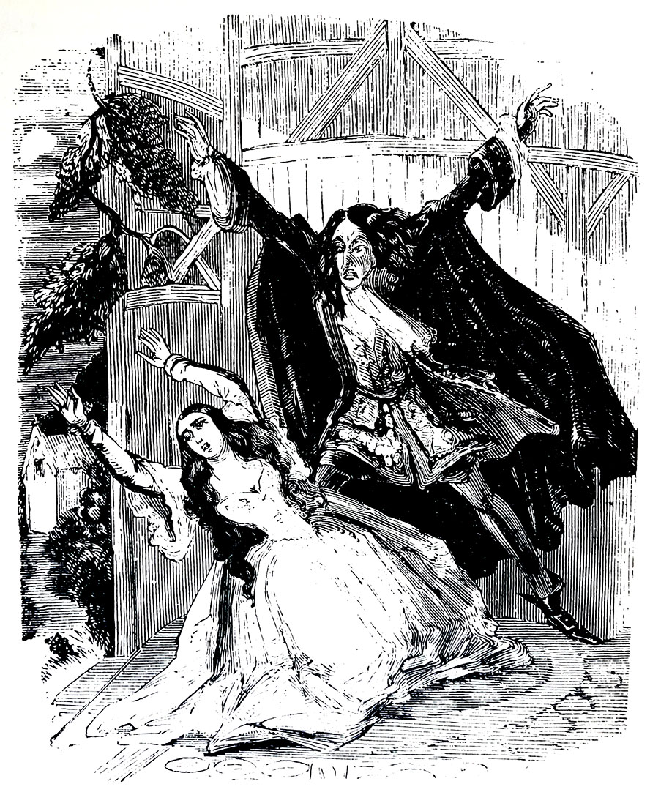
Daring, Deadly, and Dreadful:Victorian Monsters Through the Centuries

Class Time: MTWTH 9:30-10:20
Location: CMU 326

Instructor Contact Information:
Name: Nicole Peters
Email: petersnc@uw.edu
Office Hours: T/TH 1:00-2:00
Office Location: Padelford B-34

Course Description

“Death! He shuddered at the idea--and yet he never sought to escape from its presence by conversation or books. He sat moodily brooding upon death and what would probably occur hereafter, until he conjured up to his imagination all the phantasmagorical displays of demons, spectres, and posthumous horrors ever conceived by human mind.” --George W. M. Reynolds, The Mysteries of London

Many of our iconic monsters can be traced back to Victorian England’s literary culture. The nineteenth century was a period of rapid change--a time of scientific discovery, industrialization, consumer growth, and colonial power. The country’s anxieties surrounding these changes were reflected in the popular literature it produced and consumed. In this class we will look at some of these famous (and not so famous) monster figures and trace their afterlives in contemporary texts through horror, mystery, and mashup genres. While thinking about what it means to be a “monster” (in Victorian terms and our own), we will also consider how Victorian monsters engaged with questions of class, gender, race, and materiality. Authors will include George W. M. Reynolds, Christina Rossetti, Mary Shelley, Robert Louis Stevenson, Bram Stoker, and more.

This course fills the University of Washington's "W" Writing Credit. Your writing will include weekly discussion posts, in-class free writes, and two papers.

Course Goals
- Students possess critical reading skills that include the ability to close-read and to analyze literary texts within their particular social, historical and cultural contexts
- Students can begin to articulate the value of discussing and interrogating literature and popular culture.
- Students are able to form complex, analytical claims supported with textual evidence in writing about literature and culture
Required Texts

Frankenstein, Mary Shelley
Strange Case of Dr Jekyll and Mr Hyde, Robert Louis Stevenson
The Island of Dr. Moreau, H.G. Wells
Carmilla, Sheridan Le Fanu
Dracula, Bram Stoker
Stalking Jack the Ripper, Kerri Maniscalco
LOEG Volume One, Alan Moore

**you will also need to print out pdfs I provide on canvas

Assessment

Participation: 25
Midterm 20
Final 35 (in class exam and take home essay)
Discussion/Blog Posts 20
Participation
Please note that this class requires a heavy reading load and meets four days a week at 9:30 am. Your participation during every single class period is essential to your success in this course. If you fall behind in the reading, please come talk to me as soon as possible—do not miss class. Participation scores will be evaluated by your ability to be engaged during every class which means:
- showing up on time and prepared everyday
- listening actively to classmates
- speaking up during discussions
- participating in group work and peer revision
- completing the required reading--carefully--and passing reading quizzes.

Tentative Reading and Blog Schedule:
Date | Reading | Blog/Paper Schedule
Week 1
Mon 1/6 | Syllabus Day
Tues 1/7 | “Goblin Market,” Rossetti
Weds 1/8 | Frankenstein Letter 1--Ch 6 (approx 35 pages)
Thurs 1/9 | Frankenstein Ch 7--14 (approx 35 pages)
Week 2
Mon 1/13 | Frankenstein Ch 15--21 (approx 35 pgs) | First Readers (Group 1)
Tues 1/14 | Frankenstein ch 22--end (approx 25 pgs) | Second Responders (Group 2)
Weds 1/15 | Young Frankenstein (1974) | Synthesizers (Group 3)
Thurs 1/16 | Hutcheon, Linda “Parody Without Ridicule: Observations on Modern Literary Parody”  “Frankenstein,” William St. Clair
Week 3
Mon 1/20 | No Class--MLK Day | First Readers (Group 3)
Tues 1/21 | Strange Case of Dr. Jekyll and Mr. Hyde | Second Responders (Group 1)
Weds 1/22 | Strange Case of Dr. Jekyll and Mr. Hyde | Third Synthesizers (Group 2)
Thurs 1/23 | “The Jekyll and Hyde of the Atomic Age: The Incredible Hulk as the Ambiguous Embodiment of Nuclear Power,” Adam Capitanio
Week 4
Mon 1/27 | The Island of Dr. Moreau, Ch1-10 (approx 35 pages)  Jack the Ripper discussion | First Readers (Group 2)
Tues 1/28 | The Island of Dr. Moreau, Ch 11-16 (approx 40 pages) | Second Responders (Group 3)
Weds 1/29 | The Island of Dr. Moreau, Ch 17--end (approx 25 pages); | Third Synthesizers (Group 1)
Thurs 1/30 | Stalking Jack the Ripper ch 1-5 (approx 50 pages)
Week 5
Mon 2/3 | Stalking Jack the Ripper ch 6-9 (approx 50 pages) | All Groups: Midterm proposal paragraph due by 11:59 PM
Tues 2/4 | Stalking Jack the Ripper ch 10-15 (approx 60 pages)
Weds 2/5 | Stalking Jack the Ripper ch 16-19 (approx 50 pages)
Thurs 2/6 | Stalking Jack the Ripper ch 20-24 (approx 50 pages) | All Groups: feedback on two peer proposals (150 words each) by 11:59 pm
Week 6
Mon 2/10 | Stalking Jack the Ripper ch 25-end (approx 65 pages) | All Groups: Respond to Blog prompt
Tues 2/11 | Mysteries of London  TBD | Paper due in class and on canvas
Weds 2/12 | String of Pearls  TBD
Thurs 2/13 | Sweeney Todd (2007)
Week 7 | Vampires
Mon 2/17 | No Class--Presidents Day | First Readers (Group 1)
Tues 2/18 | Carmilla | Second Responders (Group 2)
Weds 2/19 | Carmilla | Synthesizers (Group 3)
Thurs 2/20 | Carmilla web series/film  (TBD)
Week 8 | Vampires
Mon 2/24 | Dracula excerpt | First Readers (Group 3)
Tues 2/25 | Dracula excerpt | Second Responders (Group 1)
Weds 2/26 | Dracula excerpt  Thomas, Ronald “Specters of the Novel: Dracula and the Cinematic Afterlife of the Victorian Novel” | Third Synthesizers (Group 2)
Thurs 2/27 | A Girl Walks Home Alone at Night (2014)
Week 9 | Vampires/Steampunk
Mon 3/2 | Buffy The Vampire Slayer (“Buffy vs. Dracula);  Vampires in popular culture today | First Readers (Group 2)
Tues 3/3 | LOEG ch 1-3  Vandermeer, Ann and Jeff, “What is Steampunk?” | Second Responders (Group 3)
Weds 3/4 | LOEG 4-end | Third Synthesizers (Group 1)
Thurs 3/5 | Penny Dreadful, episodes 1-3
Sunday 3/8*** |  | All Groups: 1 paragraph paper proposal by 11:59 pm
Week 10 | Steampunk/Mashup
Mon 3/9 | Penny Dreadful episodes 4-6  Nevins, Jess “The 19th-Century Roots of Steampunk”
Tues 3/10 | Penny Dreadful episodes 7-8  Sadoff and Kucich, “Histories of the Present” | All Groups: feedback on two peer proposals (150 words each) by 11:59 pm
Weds 3/11 | Review, evaluations
Thurs 3/12 | Final (in class)
Finals Week
 |  | Final Paper Due: 3/18 by 11:59 pm
**Please note: This schedule is tentative and will likely be shifted and changed in order to meet class/student needs. I reserve the right to add/delete assignments and readings as I see fit.

Weekly Blogging Prompt
Our course blog is an extension of our in-class learning community. It’s a place where you can track your reading process and work through thoughts, reactions, and questions in informal, low-stakes writing. Your blog posts should be coherent and proofread, but you don’t need to have a fully formed thesis. In fact, you may find that you raise more questions than you answer in your weekly writing (and that’s great!). You’ll also find that your classmates’ ideas and interpretations can serve as catalysts for your own analysis later in our formal writing assignments. In addition to the assigned reading for each class period, you should also keep up with the blog and come to class prepared to incorporate some of the blog material into our in-class discussions. You do not need to read every single comment, but rather skim most, and read several posts that interest you more closely. Our class will be divided into three different teams. Each post, whether you’re a first reader or respondent, should be 300 words minimum and quote directly from the text. Each week, you need only fulfill one role on the blog:

First Readers: post initial reactions and insights that lead into at least one discussion question by the start of class Monday. Reference the text at least once.
Second Responders: build upon, challenge, or clarify first readers’ posts by the start of class Tuesday. Respond directly to a classmate’s post, and point to at least one specific passage from that day’s reading.
Third Synthesizers: no writing on the blog required, but you should read several of your classmates’ posts (3-4) that interest you. You are reading more closely to make connections and raise new questions. Take notes and be prepared to contribute to class discussion.

I understand that in college, life happens and midterms/workloads can catch up to you. Therefore, during the quarter you may choose to skip your role as First Reader or Second Responder ONE TIME. Just post a comment on that week’s blog stating that you are using up your freebie.
Rubric for Blog Posts
3 | Excellent--The post is focused and coherently integrates examples with explanations and analysis. The post asks a thoughtful and complex question about the text and reflects in-depth engagement with the topic.
2 | Underdeveloped--The post is mostly description of summary, without consideration of alternative perspectives, and few connections are made between ideas. The post reflects passing engagement with the topic.
1 | Limited--The post is unfocused, or simply restates previous comments, and displays no evidence of student engagement with the topic.  Alternatively, post is incomplete and does not meet word minimum
0 | No credit--The post is missing, late, or consists of one or two disconnected sentences.

Late Policy
Papers are due when they are due--please turn them in on time. For each day a paper is late, you will lose half a grade point and late papers will not receive written feedback. This means that if you turn a paper in two days late and earn a 3.5, it becomes a 2.5. If you feel that you are unable to meet a paper deadline, please contact me 48 hours in advance to request an extension. I do not guarantee that I will give you an extension, but we can try to work something out.
Academic Integrity Clause
Plagiarism, or academic dishonesty, is presenting someone else's ideas or writing as your own. In your writing for this class, you are encouraged to refer to other people's thoughts and writing--as long as you cite them. As a matter of policy, any student found to have plagiarized any piece of writing in this class will be immediately reported to the College of Arts and Sciences for review.
Zero Tolerance Policy
Racism, sexism, homophobia, and other forms of discrimination and bias are hurtful and unacceptable. There is no tolerance for words, speech, behavior, actions, or clothing/possessions that insult, diminish, demean, or belittle any individual or group of persons based on race, ethnicity, religion, gender, sexual preference, ability, economic class, national origin, language, or age. Academic freedom, freedom of speech, and freedom of discourse DO NOT protect racism or other acts of harassment and hate. Violations of this Zero Tolerance Policy may result in removal from the classroom and actions governed by the student code of conduct will be taken.
Accommodations Clause
If you need accommodation of any sort, please let me know so that I can work with the UW Disability Resources for Students Office (DRS) to provide what you require. This syllabus is available in large print, as are other class materials. More information about accommodation may be found at http://www.washington.edu/students/drs/.
Writing Resources:
- Odegaard Writing and Research Center offers free tutoring to all UW students by appointment as well as free targeted tutoring for English language learners in composition courses. You can sign up for an appointment here: http://depts.washington.edu/owrc/signup.php
- CLUE, The Center for Learning and Undergraduate Enrichment, offers free drop-in tutoring for all UW students.
- The Instructional Center offers free drop-in tutoring for all UW undergraduates affiliated with the Office of Minority Affairs and Diversity.
- Student-Athlete Academic Services offers academic support to UW student-athletes.
- Check with individual departments to see if they have a writing center or suggested writing tutors.

