English 502: Compilational Reading and Middle English Romance

Dr. Leila K. Norako
Email: lknorako@uw.edu
Office: Padelford A-309
Office hours: Wednesdays, 9-10:30am

Course Description:
This seminar, which fulfills the manuscript studies requirement for the Textual Studies certificate, will both introduce graduate students to the capacious genre of late Middle English romance and invite students to explore the radically different ways in which these texts have been received over time. The first half of the course will situate students in the genre and tradition of late Middle English romance through the study of a select number of texts (such as Isumbras, Richard Coer de Lyon, Sir Gowther, and Sir Eglamour of Artois). Particular attention will be paid to the representation of gender and also premodern race-making that medieval romance frequently enacts in its world-building. To that end, we will have the pleasure of hosting Geraldine Heng in the first week of the course whose landmark books Empire of Magic: Medieval Romances and the Politics of Cultural Fantasy and The Invention of Race in the Middle Ages have encouraged increased attention to the formation of premodern racialized discourse.
The second half of the course will build off of this work and invite students to investigate how our readings shift once we begin to consider not only the manuscript provenance of these texts, but the ways in which the texts are positioned and compiled, drawing inspiration from Arthur Bahr’s innovative book Fragments and Assemblages. We will focus directly on Arthur Bahr’s work in Fragments and Assemblages, where he invites those who study medieval literature to read “compillationally,” and we will have the pleasure of having him visit at mid-quarter to discuss his past and current work. In this portion of the course, we will revisit the romances covered in the first half of the class, exploring how our understanding/interpretations shift when we encounter these texts in ways that account for their material manuscript contexts (especially as their meaning might be informed by the other texts with whom they share textual space, and also how the compilers selected the works in question and ordered them in the manuscript). Our work will involve reading other texts housed in the same manuscript, visiting our rare books library, participating in a scribal workshop (the TS department is helping me purchase quills, iron gall ink, and parchment), and more.
On Grading: Students will be evaluated on their active participation in class and through the successful completion of the assignments they self-select through the course assignment menu (see below). The grade breakdown will vary from student to student, but participation will count for 40% of your grade (this includes participating and attending the two lectures by Geraldine Heng and Arthur Bahr, barring urgent family/personal/work conflicts of course). Please reach out at any point during the quarter for updates on your grade-to-date if you’re uncertain!

Grading Scale
3.7 and above = A (you’re doing fine)
3.6 and below = B (we should talk)

Course Assignment Menu: In order to help make this class one that will maximally benefit folx at both grad and undergrad levels, I’ve chosen to take inspiration from Dr. Victoria Ford Smith at Uconn and offer an assignment menu in lieu of a mandated set of assignments. As I mentioned before the start of term, you have until Wednesday of next week to submit a proposal of the work you have decided to do, and I’d ideally like to see each of you either Wednesday during office hours or by appointment on Friday of that week to go over everything in person. While you must pick one assignment from each section, you are not obligated to follow a particular track unless you want to do so.
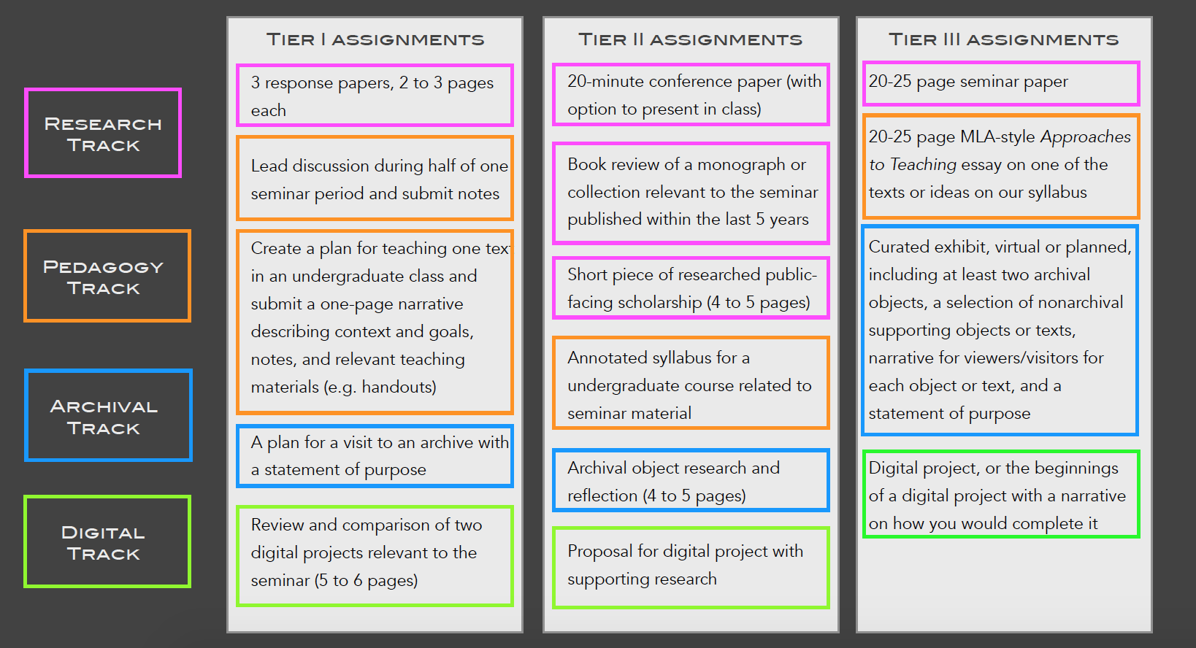

Required Texts:

n.b.: All readings aside from these will be available through Canvas. You’ll be able to find them by heading to our Assignments section and clicking on the particular week.

- Siege of Jerusalem, ed. Boyarin: https://broadviewpress.com/product/the-siege-of-jerusalem/#tab-description
- Richard Coer de Lyon. Either of these will be fine:
  - *Katherine Terrell’s translation: https://broadviewpress.com/product/richard-coeur-de-lion/#tab-description
  - Peter Larkin’s student-friendly edition (available for free online, see Canvas for link)
- *Sir Gawain and the Green Knight, ed. Winny.
- *Cleanness: https://broadviewpress.com/product/cleanness/#tab-description

Course Schedule:

Week 1 Introduction to Medieval Romance and Premodern Race-Making

January 6th : Introductions to the Genre
- Read TWO of following:
  - Susan Crane: Insular Romance (selections)
  - James and Peggy Knapp: Medieval Romance and the Aesthetics of Possibility (introduction)
  - Helen Cooper: The English Romance In Time (selections)
  - Hahn and Dana Symons: “Middle English Romance”
- Read
  - Geraldine Heng: Empire of Magic (Introduction)

January 8th: Medieval Race-making and Romance (Gerry Heng Visit and Talk)
- Read The King of Tars, https://d.lib.rochester.edu/teams/text/chandler-the-king-of-tars
- Read Heng, Invention of Race (Beginnings, Chapters 1 and 3)
- Revisit: The Man of Law’s Prologue and Tale
- Revisit: Cord Whitaker’s OACCT article on the MLT

Geraldine Heng’s Lecture: 4:30pm, Smith Room (Suzallo)

Week 2 Auchinleck Romances, continued

January 13th: Otuel, Sir Orfeo
- Read Otuel and Roland: https://archive.org/details/taillraufcoilye00herrgoog/page/n90
- Read Sir Orfeo (Intro and Lay): https://d.lib.rochester.edu/teams/text/laskaya-and-salisbury-middle-english-breton-lays-sir-orfeo-introduction
- Read Megan Leitch, “Middle English Romance: The Motifs and the Critics”
- Read Neil Cartlidge, “Medieval Romance Mischief”

January 15th: Richard Coer de Lyon, Part I
- Read Richard Coer de Lyon (Larkin edition or Terrell Translation)
- Read and compare the online Auchinleck version of RCL (Entitled “King Richard”) and peruse the digitized facsimile and website: https://auchinleck.nls.uk/editorial/bibliography1.html
- Read Marissa Libbon, “The Invention of King Richard”

Week 3 Thornton Romance Pt. I

January 20th: No Class, Martin Luther King Day

January 22nd: Richard Coer de Lyon Part II
- Revisit Richard Coer de Lyon (Larkin or Terrell)
- Read Geraldine Heng, Empire of Magic, Chapter 2
- Read Suzanne Akbari, “The Hunger for National Identity in Richard Coer de Lyon”

Week 4 The Thornton Romances, Part II (Secondary readings tbd)

January 27th Sir Isumbras and Sir Degrevant

January 29th Sir Perceval of Galles

Week 5 The Gawain Poet

February 3rd Sir Gawain and the Green Knight
- Read or revisit SGGK in translation
- 1-2 articles tbd

February 5th Pearl
- Read Pearl (METS edition or Armitage translation)
- Read Bahr, “The Manifold Singularity of Pearl.”

Week 6

February 10th : Compilational Reading and Medieval Manuscripts, An Introduction
- Read Fragments and Assemblages (Introduction, Chapters 1, 2, and 3)
- Read Excerpts from Kathryn Kerby-Fulton’s Opening Middle English Manuscripts (TBD)
- Revisit Excerpts from Opening Middle English Manuscripts

February 12th: Arthur Bahr Visit and Talk, Readings TBD (related to Pearl Manuscript though)

Week 7

Feb 17th: No Class, President’s Day

Feb 19th: Medieval Manuscripts/Rare Books visit.
- Readings TBD

Week 8

Feb 24th : Scribal Workshop/Cotton Nero Discussion.
- Read Cleanness
- Read Patience.
- Peruse the Cotton Nero A.ii website.
- Read Maidie Hilmo, “Illustrating the Gawain Manuscript.”
- Read Maidie Hilmo, “Reconceptualizing the Poems of the Pearl-Gawain Manucript in Line and Color”

Feb 26^{th:} Cotton Nero Discussion continued. Read Bahr’s recent work on Pearl Poet. Read Pearl, Cleanness, and Patience. Explore the Cotton Nero project.

Week 9

March 2nd : Auchinleck.
- Read The lives of St. Katherine and St. Margaret (mets versions) and then take a look at the Auchinleck versions themselves to see how they compare.
- Read Excerpts from The Auchinleck Manuscript, New Perspectives (Intro, Chapters 1-2)
- Read Calkin, Saracens and the Making of English Identity, Chapter 4

March 4th : Thornton, revisited
- Read St. Christopher
- Read The Awynters.
- Read “Robert Thornton Reads Romance.”

Week 10

March 9th : Thornton. Read Siege of Jerusalem. (read Boyarin’s introduction)

March 11th : Course-wrap-up, final project workshopping

