ART 350
Spring Quarter 2020 Monday/Wednesday 11:30-2:20

Advanced Drawing into Printmaking
5 Credits

Spring Print Courses Link
https://drive.google.com/drive/folders/1wE2DdEOVUl69Cq0ORslXGUBtcpxPhXWh

Instructor: Curt Labitzke cwl@uw.edu
Instructional Technician: Kim van Sommeren kimvs@uw.edu

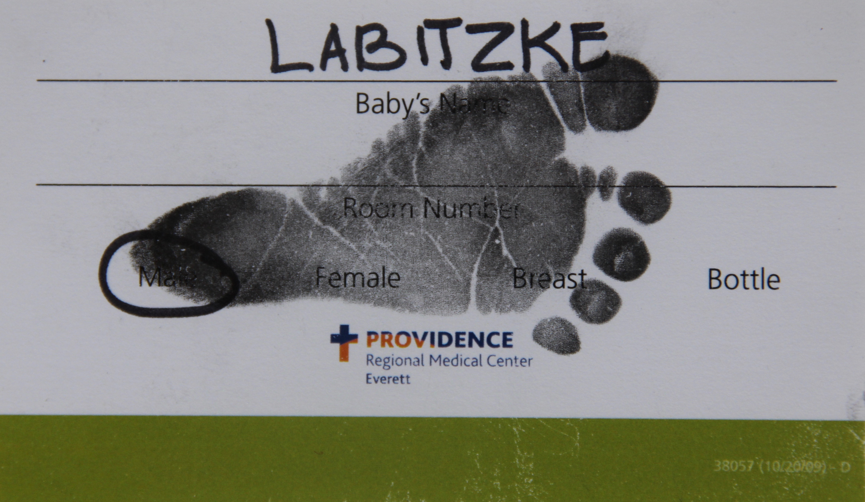

This class will not meet on campus Spring Quarter 2020.
All work will be completed at home in individual studio spaces.

This course will be a numerically graded course.

Students are required to spend a minimum of 15 hours per week, including class time, for this course.

Advanced Drawing into Printmaking is a hybrid studio art class that mixes direct drawing methods using a variety of different materials and tools along with immediate/direct printmaking techniques to include transfer printmaking, stenciling, rubbings, collaging and various direct and indirect drawing and painting techniques.

Students will be asked to design two individual projects this quarter based upon their goals, interests, abilities and limitations in consultation with the me.
20% of Final Grade. 20% for Each

In addition, students will be responsible for weekly assignments that will include a research component and a minimum of two hours of drawing. Due most Monday afternoons after class.
25% of Final Grade. 5% per week

A short, one page, research project related to their work.
20% of Final Grade.

Log book of hours per day per week spent with course work and a final course summary.
15 % of Final Grade.

Please note: Calendar, syllabus and assignments subject to change throughout the quarter. If changes are made you will have plenty of advanced notice.

Calendar

Week 1
Mon March 30 First day of class. Welcome back! 11:30 ZOOM MEETING LINK.
Introductions and overview of course. Getting started.
Start collecting supplies for your own personal studio set up at home.
Start drawing at home for first project. Begin individual research.
Draft a project proposal for the first four weeks of the quarter.
No donuts unfortunatly!

Wed April 1 11:30-12:30 ZOOM MEETING LINK. Questions, thoughts, comments.
Studio work time. Post image of your work space to Canvas today.

Week 2
Mon April 6 11:30 ZOOM MEETING LINK. Weekly Independent research and
drawings/sketches due today to Canvas.
Submit draft of individual proposal for the next three weeks of the
quarter. Project due Wednesday April 22.

Wed April 8 11:30-12:30 ZOOM MEETING LINK. Start working from home. Check
Canvas assignment 1 comments. Studio Work Time
Curt available via Zoom.

Week 3
Mon April 13 11:30 ZOOM MEETING LINK. Weekly Independent research and
drawings/sketches due today.

Wed April 16 11:30-12:30 ZOOM MEETING LINK. Check Canvas assignments.
Studio Work Time
Curt available via Zoom.

Week 4
Mon April 20 11:30 ZOOM MEETING LINK. No weekly Independent research and
drawings/sketches due today.

Wed April 22 11:30 ZOOM MEETING LINK First project due today. Post to Canvas by
the end of today.

Week 5
Mon April 27 11:30 ZOOM MEETING LINK. Weekly Independent research and
drawings/sketches due today.

Wed April 29 11:30-12:30 ZOOM MEETING LINK Submit draft of individual proposal
For second project of the quarter. Project due Wednesday June 10.

Week 6
Mon May 4 11:30 ZOOM MEETING LINK. Weekly Independent research and
drawings/sketches due today.

Wed May 4 11:30-12:30 ZOOM MEETING LINK. Studio Work Time
Curt available via Zoom

Week 7
Mon May 11 11:30 ZOOM MEETING LINK. Weekly Independent research and
drawings/sketches due today.

Wed May 13 11:30-12:30 ZOOM MEETING LINK. Studio Work Time
Curt available via Zoom

Week 8
Mon May 18 11:30 ZOOM MEETING LINK. Weekly Independent research and
drawings/sketches due today.

Wed May 19 11:30-12:30 ZOOM MEETING LINK. Studio Work Time
Curt available via Zoom

Week 9
Mon May 25 Memorial Day. No weekly Independent research and
drawings/sketches due today. Go for a walk.

Wed May 27 11:30-12:30 ZOOM MEETING LINK. Studio Work Time
Curt available via Zoom
.
Week 10
Mon June 1 11:30 ZOOM MEETING LINK. Studio Work Time
Curt available via Zoom.

Wed June 3 11:30 ZOOM MEETING LINK Last Day of Classes. Studio Work Time
Curt available via Zoom.

Wednesday June 10 2:30-4:30 Final Exam Period
2:30-4:20 ZOOM MEETING LINK

Final Portfolio Images due to Canvas by end of the day.
Log book of time spent per day on this course.
Summary of your progress this quarter.
Create Google Doc Gallery of Art 350 works.

SUMMER BREAK!

Important Information for all Students

Equal Opportunity
The School of Art reaffirms its policy of equal opportunity regardless of race, color, creed, religion, national origin, gender, sexual orientation, age, marital status, disability, or status as a disabled veteran or Vietnam-era veteran in accordance with UW policy and applicable federal and state statutes and regulations.

Disability Accommodation
- If you would like to request academic accommodations due to a disability, please contact Disabled Student Services, 448 Schmitz, (206) 543-8924 (V/TTY) or uwdss@u.washington.edu.
- If you have a letter from Disabled Student Services indicating you have a disability that requires academic accommodation, please present the letter to me so we can discuss the accommodations you might need for the class.

Participation Policy
- Absences from class prevent participation and may negatively affect grades.
- If you miss class due to illness or emergencies immediately notify your instructor and insure that all missed assignments and exams are completed.

Plagiarism
- Plagiarism is defined as using in your own work the creations, ideas, words, inventions, or work of someone else without formally acknowledging them through the use of quotation marks, footnotes, bibliography, or other reference.
- Please check with your instructor if you have questions about what constitutes plagiarism.
- Instances of plagiarism will be referred to the Vice Provost/Special Asst to the President for Student Relations and may lead to disciplinary action.

Incomplete Grades an incomplete is given only when you:
- Have been in attendance and done satisfactory work through the eighth week of the quarter.
- Have furnished satisfactory proof to the instructor that the work cannot be completed because of illness or other circumstances beyond your control.

Concerns about a course, an instructor, or a teaching assistant
- Talk with the instructor in charge of the class as soon as possible.
- If you are not comfortable talking with the instructor or are not satisfied with the response that you receive, you may contact the Director of Advising and Student Services, Judith Clark, Art 104, 206-543-0646
- If you are not satisfied with the response that you receive you may contact the Chair of the School o f Art, Christopher Ozubko, 102 Art.

Examination Schedule
- Students are required to take exams as scheduled.
- Exceptions are granted in cases of documented emergencies and must be approved by instructor.

Grade Appeal Procedure If you are concerned that the grade you received for a class is incorrect:
- Contact the instructor who issued the grade and discuss the matter with her/him.
- If not resolved to your satisfaction make an appointment with the Director of Academic Advising and Student Services, Judith Clark, 104 Art, 543-0646.
- If necessary submit a written appeal to the Director of the School of Art who will take the matter under advisement and call a faculty committee to review the student’s course work and make a final determination concerning the grade dispute.

Materials Fees
- All art and art history classes have materials fees that are billed on your tuition statement. Information is available in 104 Art.
- If you drop a class in the first five days of the quarter, the fee is automatically removed from the quarterly billing.
- If you drop after the first five days (and before using any class materials) you must petition for a refund. Studio Art Fee Refund Petitions are available in 102 Art.
- The School of Art cannot process any petitions received after noon on the last day of the quarter.

Building Use Policy
- The Art building is open to students 365 days a year from 6am to 11pm.
- Students wishing to work in the building after 11pm obtain a key and building pass from Ann Greene in 102 Art.
- For the safety of our students, the campus police frequently monitor the facility. Individuals found without a pass may be asked to leave the building.
- All students working after hours in the studios and classrooms must maintain quiet, refrain from tampering with the work of others, and follow all regulations established by the faculty for each classroom/studio.
- Students who are not enrolled in classes for the quarter may not use the facilities, classrooms or studios in the School of Art.
- All students taking studio classes are expected to follow faculty direction in terms of keeping classrooms clean, safe, and workable for themselves and others.

Locker Policy –
- DO NOT STORE FLAMMABLE OR COMBUSTIBLE ITEMS IN LOCKERS
- The Academic Advising & Student Services Office, 104 Art rents lockers, by the quarter or academic year, on the first day of each quarter.
- No refunds will be made for unused or returned lockers.
- The deadline for cleanout is the last day of finals for each quarter. Items found in lockers after the deadline will be discarded. If you choose not to renew, please bring your lock back to 104 Art.

Safety
- Many of the substances and equipment used in creative processes can be hazardous to you and others if used incorrectly. Enrollment in a class requires the student to know, understand and comply with all safety and equipment use policies in each classroom/studio. These guidelines are distributed to students on the first day of each class.
- Art Hazards in the School of Art handout is an excellent beginning resource for learning about these dangers. This handout is available in the Academic Advising and Student Services Office (Room 104).
- Material Safety Data Sheets, and information on hazardous waste disposal, UW Health & Safety Policy and art hazards are available from the School of Art Administrator (102 Art) and on reserve in the Art Library.
- Spray booths are provided for use of aerosols and their use is mandatory.

Copy Write Policy
The SoA regularly displays works of art that students create in class, images of student works, and images of students participating in SoA activities. We do this to promote our students, their work and the School, and the ways we display student works and related images vary widely. Use of such images is traditional among all art schools and we assume that by participating in UW SoA classes and activities students have no objection. However, if you do have concerns about these image uses, please contact Academic Advising and Student Services (206-543-0646 or uaskart@u.ashington.edu).

