CMS 397/ENGL345 American Independent Film Spring 2020

Instructor: Kimberlee Gillis-Bridges
Phone: [phone number removed]
Email: [email address removed]
Zoom Live Meeting Access: [Zoom link removed]
Zoom Office Hours: Tuesday, 11:30 a.m.-12:30 p.m. at [Zoom link removed], and by appointment
Course Canvas Site: [link removed]

Description

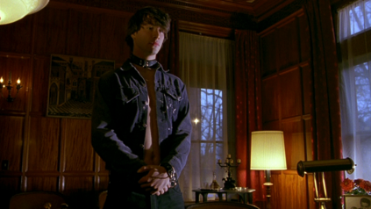
What constitutes “independent film” in an era where both filmmakers who distribute their work online and boutique divisions within Hollywood studios lay claim to the term? Our course addresses this question by examining the narrative, stylistic, industrial and cultural aspects of contemporary U.S. independent film. We will begin by examining the early work of John Cassavetes, the “father” of American independent film before turning to the burgeoning of independent cinema that began in the late 1980s. Along the way, we will discuss movements like New Queer Cinema, mumblecore, and Black surrealism. In addition to viewing assigned films via the course Canvas site, students will attend selected online screenings at the Northwest Film Forum or streaming showings with Q&A of films from Sundance, Toronto, and other recent festivals.
My Own Private Idaho (Gus Van Sant, 1991)

The course meets online, with a blend of asynchronous and synchronous activities. Our Canvas course site features modules with information on all required readings, screenings, quizzes, assignment prompts, discussion activities, and live course sessions.

Cinema and Media Studies 397/English 345 fulfill the University’s VLPA requirement and count toward English or Cinema Studies major requirements.

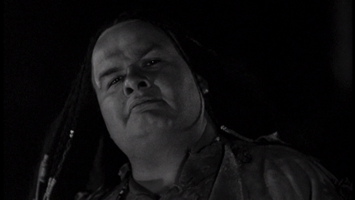
Course Goals and Methodology

Overall, students in the course learn to read film formally, theoretically, and contextually and develop as critical thinkers and writers. By the end of the course, students should be able to:

- Identify films’ narrative, visual, and sound techniques, using vocabulary specific to cinema studies.
- Analyze how independent films use artistic strategies to achieve a range of effects.
Dead Man (Jim Jarmusch, 1995)
- Evaluate how independent films respond to and shape cultural, historical, and industrial contexts; circumstances of production; genres; and film movements.
- Develop complex written arguments and support those arguments with sufficient and appropriate evidence.
- Engage the work of film scholars, critically responding to their ideas in discussion and writing.

Whether synchronous or asynchronous, course activities promote active learning. Expect a blend of short lectures, discussion, polls, and individual writing. My role is to provide the tools and resources; you will need to advance your own thinking and writing. I will pose questions, design activities to help you think through these questions, and respond to your ideas. Your role is to do the hard work—the critical reading, discussion, and writing. You will analyze films, generate ideas with peers, verbally analyze film clips, and construct written arguments.

Requirements

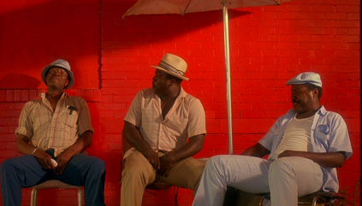
Class Participation

Class discussion constitutes one key method of developing your analytical skills. Thus, I expect regular, active participation in discussions of films and readings. You should prepare for each discussion—whether live or asynchronous—by completing assigned readings and taking notes during screenings. You should also plan to ask questions, respond to peer comments, summarize scholars’ arguments, analyze clips, paraphrase your film responses, or contribute to small-group exchanges. Like all skills, participating in class becomes easier with practice. I do not expect fully polished analyses; rather, your contributions spark further discussion and may become the basis for other assignments. There are several ways you can participate in the course:
Do The Right Thing (Spike Lee, 1989)

- Completing required written replies to peers’ film responses on Canvas.
- Speaking to the whole class or small groups of peers during live class sessions.
- Asking questions, commenting or taking notes via Zoom chat during live class sessions.
- Responding to polls during live class sessions.
- Posing or answering questions on the module check-in spaces.
- Giving feedback on peers’ work-in-progress.
- Discussing films, ideas-in-progress, or questions with Kimberlee during Zoom drop-in hours.

Because students will have multiple, sometimes conflicting, interpretations of course films, we will establish norms for maintaining a respectful learning climate early in the quarter. We’ll also work to develop rapport with icebreaker activities throughout the quarter.

I assess participation weekly on a credit/partial credit/no credit basis, with students who contribute in at least two of the ways outlined above with good-faith effort receiving full credit. Lack of engagement in class activities, inadequate preparation, and failure to adhere to classroom rules will substantially lower your participation grade for the course.

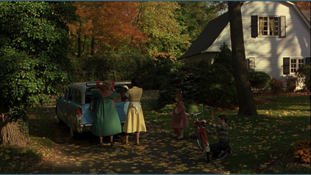
Film Responses

Students will use the class discussion board to share responses to films and readings and respond to one another’s interpretations. Each week, I will pose questions on course texts. In a 250- to 300-word response, you may address one of my questions or pose and answer a question of your own. The online film responses raise issues for further discussion—you will compose 100-word replies to two peers each week. Responses also allow students to expand on previous in-class or online conversations and develop ideas for critical annotations and essays. I assess postings on a credit/partial credit/no credit basis, with full credit granted to on-time postings that meet the length requirement and demonstrate serious engagement with the questions provided or film discussed. I will drop your lowest response score from your final grade.
Far From Heaven (Todd Haynes, 2002)

Quizzes

Students will take weekly quizzes that contain multiple-choice and short-answer questions on lecture, readings, and films. The quizzes allow me to assess your comprehension of key concepts as they encourage you to keep up with course activities. Quizzes are open-book and timed; students’ lowest score will be dropped from the final grade.

Critical Annotation

Early in the quarter, you will use the platform VideoANT to create an online analysis of how elements of narrative form, cinematography, or mise-en-scene function in a clip from Easy Rider, Faces, sex, lies and videotape, or Shadows.

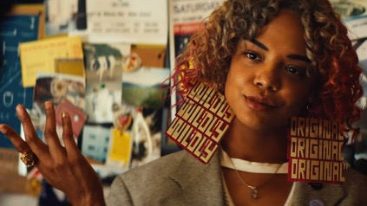
Essays

Students will compose two 1400- to 1600-word essays with screenshots on assigned topics. Each essay requires a draft that receives peer feedback. In addition, I will be available to discuss ideas-in-progress and drafts. You can also seek feedback from consultants at the Odegaard Writing and Research Center or the CLUE Writing Center, both of which will offer online sessions during spring quarter.

Please title, paginate, and double-space your essays, and set margins at one inch. In the upper left hand corner of the first page, include your name, the course number, the assignment, and the due date; this information should be single-spaced. When citing sources, use MLA 8th edition format.
Sorry to Bother You (Boots Riley, 2018)

Extra Credit

Students may receive extra credit for attending online or on-demand screenings and live social media events related to class topics, texts and filmmakers. To earn points, students must first discuss the event with me. Within one week of attending the event, students should write a 300- to 350-word analysis that briefly describes the event, explaining how the ideas and materials encountered complement, supplement or challenge our class conversation. Students attending screenings may also draw on the Film Art textbook or a critical article read for class to analyze the film. Each extra-credit piece is worth ten points; students may do a maximum of two extra-credit activities.

Policies

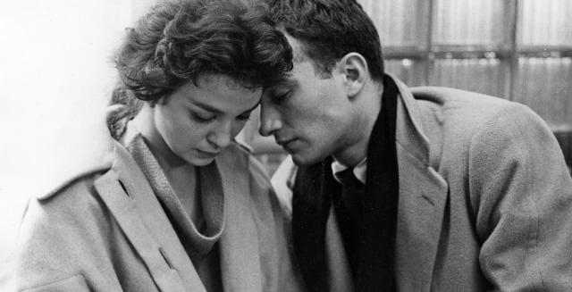
Lateness Policy

I do not accept late film responses, replies, proposals, drafts, or extra-credit write-ups. Late clip annotations and essays will receive a 10-point deduction per day late, including weekends and holidays. I will make exceptions to the lateness policy only when students becomes ill, experience family emergencies, or make prior arrangements with me.

Technology glitches do not constitute valid excuses for lateness. To avoid computer problems, you should save frequently while working, and you should back up work saved on a hard drive to Dropbox, iCloud, UW Google Drive, or your personal file space on Canvas. When submitting files or URLs to Canvas, you are responsible for copying/pasting the correct URL or selecting the correct file. If Canvas breaks down, contact UW-IT technical support (help@uw.edu) and email your work directly to me ([email address removed]).
Shadows (John Cassavetes, 1959)

Academic Integrity

Cinema and Media Studies 397/English 345 adheres to the University of Washington’s Student Conduct Code, which prohibits academic misconduct like distributing instructional materials outside class without permission, cheating and plagiarism: the unacknowledged use of others' words or ideas. All films, readings, visual aids, lectures, discussions, and other handouts are for enrolled students only. When taking quizzes, do not share questions or answers with fellow students. When drawing upon sources in your film responses and replies, critical annotation, and essays, make clear to your audience that you are incorporating others’ work by placing quotation marks around exact words and noting the author’s name whenever you quote, summarize or paraphrase. Cheating on exams and failure to credit sources may result in a failing grade for the assignment, a failing grade for the course, or other disciplinary action. Disseminating course materials without permission may result in sanctions, including dismissal. If I see evidence of academic misconduct, I will make a report to the Community Standards & Student Conduct Team.

Course Materials

Films

Our $10 course fee covers streaming of all course films. We will screen the following titles in whole or part:

- Dead Man (Jim Jarmusch, 1995, 121 min.)
- Do the Right Thing, Spike Lee, 1989, 120 min.)
- Easy Rider (Dennis Hopper, 1969, 95 min.)
- Faces (John Cassavetes, 1968, 130 min.)
- Far From Heaven (Todd Haynes, 2002, 107 min.)
- Humpday (Lynn Shelton, 2009, 94 min.)
- My Own Private Idaho (Gus van Sant, 1991, 104 min.)
- Pulp Fiction (Quentin Tarantino, 1994, 154 min.)
- The Puffy Chair (Jay and Mark Duplass, 2005, 85 min.)
- sex, lies, and videotape (Steven Soderbergh, 1989, 100 min.)
- Shadows (John Cassavetes, 1959, 81 min.)
- Sorry to Bother You (Boots Riley, 2018, 111 min.)

Textbooks

- Bordwell, David and Kristin Thompson. Film Art: An Introduction. 12th edition. McGraw-Hill Education, 2019. ISBN: 1260565661. Book available in physical format via UW Bookstore (free shipping) and in digital format via various online booksellers.
- Online readings for Cinema and Media Studies 397/English 345. Available via course Canvas site.

Additional Expenses

- Streaming media or online ticket fees for festival films released online, via streaming media, or on-demand (approximately $20-$25 total)

Assessment and Grading

Grades in Cinema and Media Studies 397/English 345 will be computed by points, with 300 points equaling a 3.0, 200 points a 2.0, and so on. If your total falls between grades, I will round up if you score one to five points below the higher grade and round down if you score one to four points above the lower grade. For example, 274 points equals a 2.7 and 275 points a 2.8. Students who score less than 65 points total will receive a 0 for the course, as the UW grading system does not scale grades lower than .7. I also assign a 4.0 to students who score between 385 and 400 points.

Response postings and replies receive full credit for meeting minimum length requirements and thoughtfully engaging with instructor questions or peers’ initial responses. Students who regularly participate each module in at least two of the ways outlined in “Class Participation” will receive full participation points. All other assignments are evaluated based on correctness or quality of work submitted. Assessment comes in the form of grades and instructor feedback, either free-form or within a rubric. Since this is an online course, I rely on your assignments to assess your understanding of the course content. If you do not understand course readings, films, instructional materials, or assignment prompts, ask questions in the check-in area for each module.

Total Points for the Course

Each component of the course is worth the following number of points. Please note that Canvas does not integrate well with my point schema. Canvas automatically converts points into percentages, a conversion that can make your grade seem lower than it actually is. For example, 10/20 points represents the C range under my system and the F range (50%) under a percentage system. For this reason, I include point range information on each assignment. In short, keep track of your total points and ignore Canvas's percentage conversion.

Grade Component | Possible Points
Class Participation | 60 points
Quizzes (9) | 40 points (5 points each; lowest score dropped)
Critical Film Annotation (1) | 60 points
Film Responses (9) | 80 points (10 points each; lowest score dropped)
Essays (2) | 160 points (80 points each)
TOTAL | 400 points

Accessibility and Accommodations

Your experience in this class is important to us, and it is the policy and practice of the University of Washington to create inclusive and accessible learning environments consistent with federal and state law. If you experience barriers based on disability, please visit Disability Resources for Students (DRS) online for more information about requesting accommodations. Although the building that houses DRS is closed, staff are available Monday through Friday from 8:30 a.m.-5:00 p.m. to speak with students by phone, TTY, video chat, or email (uwdrs@uw.edu).

Technology Requirements

Because all course learning takes place online, the following technology is essential to accessing materials and submitting assignments:

Reliable Internet access

Web browser and computer specifications adequate for using the Canvas Learning Management system and VideoANT

Webcam and microphone or phone camera and microphone or computer/phone audio

Word processing software. Note that although you may use any software, you must submit written assignments in PDF or Microsoft Word format (.doc or .docx). If you use any other program, use the Help function for instructions on converting your files to PDF or Word format. Students may get Microsoft Office 365 and Windows 10 for free via UWare (https://itconnect.uw.edu/wares/uware/microsoft/microsoft-software-for-students/)

Headphones or speakers (internal or external) to hear video content.

PDF viewer (Adobe PDF Reader or Apple Preview)

Basic image editing tool that allows image cropping (Paint, Preview, Paint.net, Photoshop Express)

UW Net ID and Email. The class email list uses your UW email. If you want UW email to go to another account, you may

