Paper #2 Engl 213

This paper combines what you have gained from close reading with assembling those skills in the service of critical argument. With one exception, the subject matter is drawn from two pieces of fiction from this class.

Instructions

Your final paper is 5-7 double-spaced and yet full pages, excluding notes and paratext.

Due Saturday 13 March, 10 am PST. If you wish to receive written comments, write this at the top of the first page.

You can turn in the paper in before noon Sunday 14 March without penalty, but with the understanding you’re not likely to receive comments.

1. It must have (a) an introductory paragraph (b) a thesis statement, and (c) a concluding paragraph or paragraphs. Your thesis must be a one- to two-sentence analytic position. Your thesis must underlined. Remember, you do not have to prove the existence of the universe in your final paragraph. Don’t go all “I need to write like someone’s theory of an English major and their lofty concerns” on me now. The world needs clarity, truth, and concision.
2. All quotations must be parenthetically cited by a one- or two-word italicized or underlined abbreviation of the novel’s title alongside its page number: (Swing Time, 111).
3. Do not use passages we have discussed in class. Exceptions may be requested and cleared with me 4 business days in advance of 11 March. You may not use material or passages from your first paper unless already cleared by me 4 business days in advance of 11 March.
Asking for clearance is not the same thing as receiving clearance.
Clearing something may or may not happen over email; it might require conversation.
Ergo: plan ahead.
4. You must use the techniques of close reading at least three times. Make an endnote where you are close reading. In the body of the paper it will look like the below.

… as evidenced by the use of the word "red" (Woman Upstairs, 10).²

Your paper’s final page may very well therefore look like this.

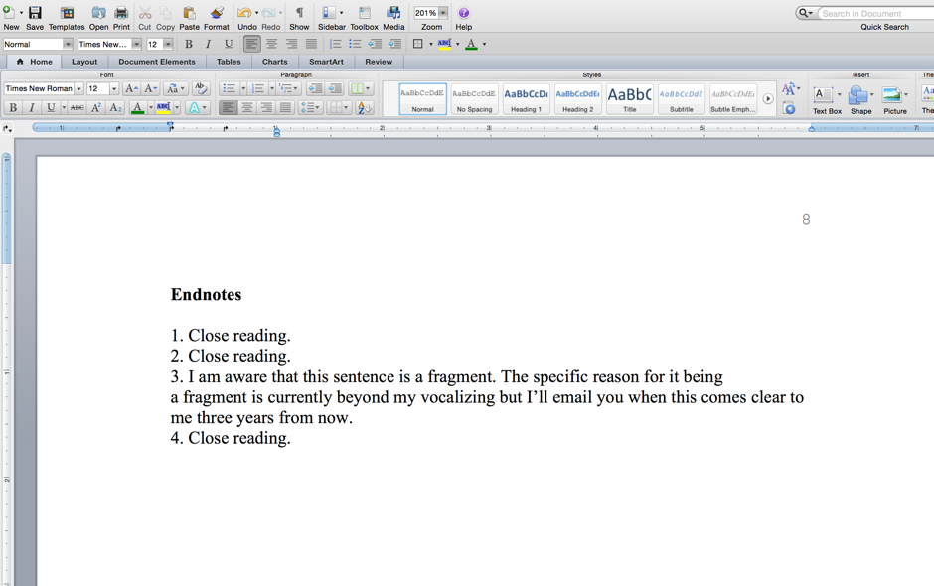
5. Quoting a text is not the same thing as close reading as text.
6. Endnotes are not footnotes.
7. If you use an edition or texts other than the ones ordered for class, provide a “Works Cited” section. A Works Cited section is not otherwise necessary. If you have a Kindle edition, please provide screen shots of your close read quotations in appendix.
8. Papers are to be submitted in Word doc or docx form.

Prompts

1. Compare kisses in Cunningham and Woolf.

2. Give three specific ways that Swing Time time contrasts with, builds on, or some other specified, critically evaluative category of connection, with time in Mrs. Dalloway. You will need to narrow this down until you can fit it through the eye of needle; as you may have noticed these novels involve time bigtime, and hauling out a general category is going to leave you staring like Johnny “We do not speak his name” Depp at the blank screen in Secret Window, and that does not end well for anyone.

3. Pick four scenes from any two of our novels in this quarter that you have not previously written about (the scenes, not necessarily the novels that share an element.

4. Compare Clarissa’s “theory” to theory in Dept of Speculation.

5. Compare the appearance of colonialism in “Araby” with Mrs. Dalloway.

6. This prompt involves only Swing Time. Bring two artworks or movies mentioned in the course of the text directly to bear on one of the novel’s major themes. You mut provide a works cited and—if a painting—a link to the image in that works cited. Benjamin’s Klee’s “angel of history” is discussed in my annotations, for example.

7. Open prompt. I strongly suggest you get this cleared with me at least one weekend in advance. Since it’s college, people, you don’t have to. But if you’ve learned nothing else from this class when it comes to thinking clearly, let it be that specificity is your friend.

Failure to observe basic format stipulations will incur the steepest penalties yet levied for the quarter. Should the desire to employ a fragment seize you it must be accompanied by the endnote noting your awareness of this condition. An additional explanation of why the fragment is being employed would be interesting for me to read, and may or may not be interesting to you to write.

You may wish to make use of the Writing Center. https://academicsupport.uw.edu/clue/subjects/writing-center/

I do not hold office hours by email. Last-minute appointments made immediately prior to the due date will be negotiated on a first-come, first-serve basis.

Semi-Redundant Last Set of Parameters.
Number your paper's own pages and give it a good title.

You will be graded on style and form as well as content. Punctuation, grammar, and syntax will be evaluated, along with organization, coherence, persuasive argumentation, cogency, and originality.

Your grade will be penalized for ungrammatical language, and the failure to conform to the rules of paper presentation outlined in your syllabus. This is all to say that the errors or infelicities that you may have made earlier will weigh more heavily on your grade than before.

Redundant but Ontologically Present In Case It Belatedly Occurs to You For The First Time

Once you've completed the paper, go do something else. Then come back to it and
(a) compare it with your earlier work and the comments those things received,
(b) as well as the stunningly prescient “Marginal Comments” guide with which you have been provided and
(c) go back over these instructions above and make sure you didn’t miss anything.
(d) Fix errors that believe it or not you didn’t see before, congratulate yourself for having become a better writer, and turn it in.

