Paper #1 315

1500-2500 words.

Research time (you plus book and notebook): 3 hours. Writing time: 6 hours. Proofing time: 1.5 hour. Do not proofread until you have taken a serious break from writing. Leave it overnight. Or at least go do the dishes.

Let me know if this estimate is woefully inaccurate in terms of your experience. It’s intended to be helpful rather than prescriptive, and your supplying reality is immensely useful.

Directions
Focusing on one of the following texts: “Mannequin,” Plum Bun, or The Return of the Soldier, and in the pithiest terms available to the grammatically correct sentence do one of the numbered options below.

Underline your thesis, and specify which option you’re pursuing by writing its number at the top of page one: Example: “Option #5.”
You do not need an introduction; your thesis could well be the first sentence, and if you choose to make that a sentence the entire paragraph, add the caveat to an endnote. It could read as “I am aware that single-sentence paragraphs are typically a bad idea. I’m deliberately deploying it here because [provide reason: it augments my argument by…./modernism is about urgency, / at my back I hear time’s wingéd chariot; / etc.].” You need to think about it, and make plain that you’re not succumbing to Engineered Word-speak.

A good title is a good thing. It can suggest a tone for the paper too.

Epigraphs are optional, but cool. They generically look like this:
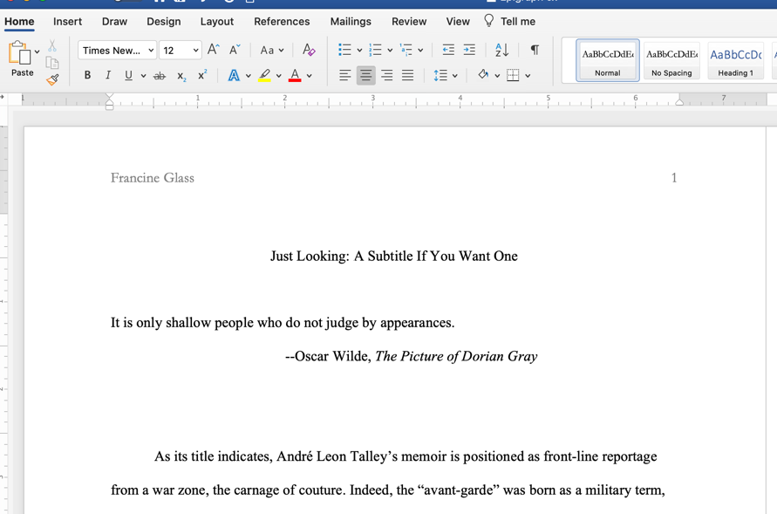
See more in Files, “Paper Titles and Epigraphs” for the full story: basically they’re quotes from an unexpected source, and groovily (sic) nail a main point about the paper.

Paper #1 Options
1. Explore the presentation of modernity in terms of one specific instance of the relationship between old and new in one of our texts.

2. Explore the presentation of modernity in terms of a specific instance of a category or image you specify in one of our texts.

3. Plum Bun has repeated references to the role of the face. To what end?

4. Name a category by which characters are known and/or judged in Plum Bun by presenting 3 concrete instances in the novel of that category. Be careful to think through its reverberations in the text. In terms of the way it is deployed in the text, is it reliable, undermined, and/or qualified?

5. To what degree does Return of the Soldier cue the reader toward its narrator as reliable or curtailed? Give 3 examples.

6. Argue for the body as a primary site of understanding a self in one of our texts--or a misbegotten one. You must use concrete textual evidence, and situate it as superior/inferior to another category of understanding the self that the text demonstrably entertains.

7. Open topic.

8. What’s the deal (sic) with the kiss in Return of the Soldier?

Read Marginal Comments in “Files” before and after you write this paper.

