Jessica Burstein 2021

Marginal Comments: The Lexicon

Comments.
Upon receiving your papers, you may find in the margins some or all of the following marks. Some of these repeated errors increasingly cost your grade. If you have a question regarding any of my comments, do not hesitate to consult me.

Make sure you view all comments on Canvas: both my overall comment and the in-paper, specific marginal comments. You may need to open your assignment again to see the latter. Do this again by clicking on “View Feedback”: see the red circle below:
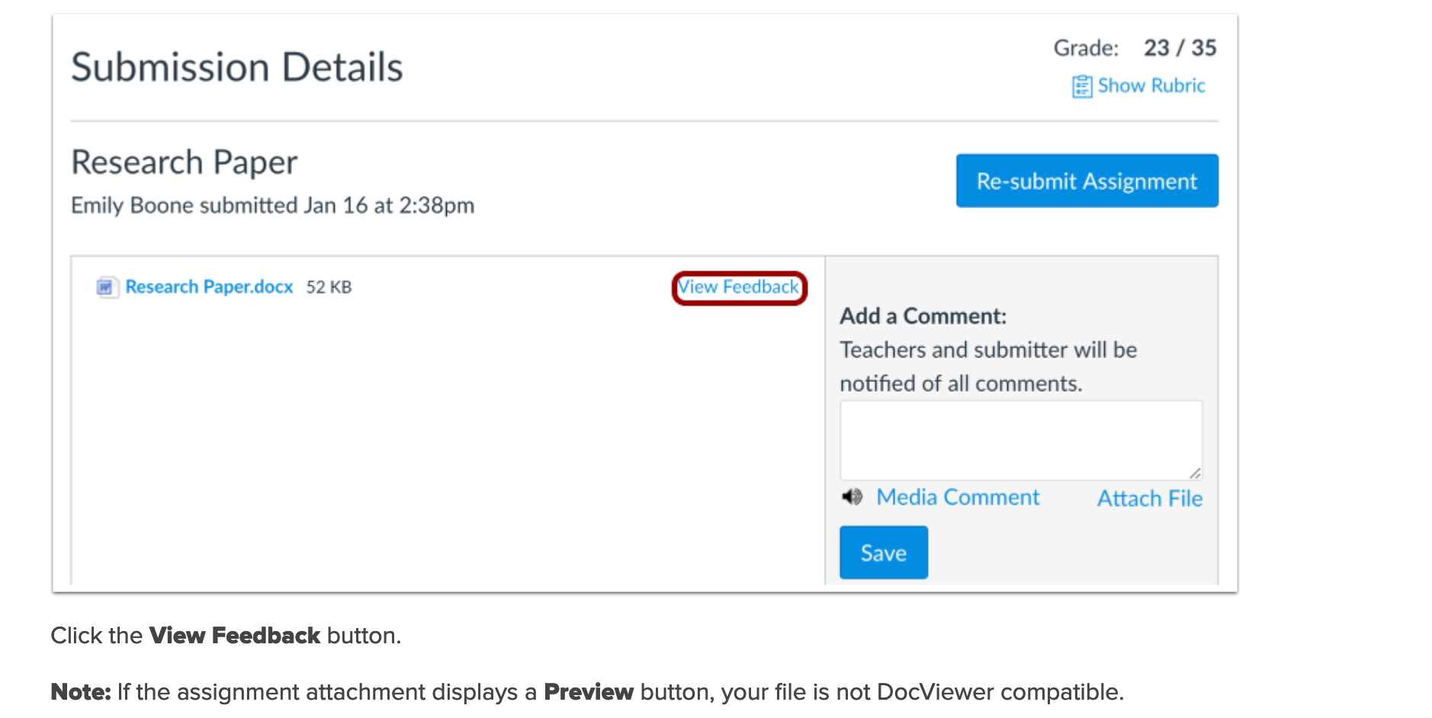

The Lexicon

PR: proofread: Reread the line next to which this appears: something is wrong in terms of what you wrote. Find it and don’t do it again. Ask me if you can’t find it.

c.s. Comma splice: joining 2 sentences with a comma, rather than treating them grammatically by (1) employing a semicolon, (2) joining them with a conjunction, or (3) severing them with a period.
This is one of the most common errors, I will grade you down for it, if you still don't know what a comma splice is you haven't read this sentence closely enough so start over.

A comma splice is cause for a check minus.
frag Sentence fragment. Do not begin a sentence with “But,” “And,” or “So.” Or "Or." That's a fragment. A fragment is cause for a check minus.

w.c. Word choice is inappropriate. Look the word up in a dictionary.

sp Misspelled word

syn Syntax is awkward

awk Awkward use of language or idea. You might see this a lot. It means it’s grammatic, but the idea is not clearly presented. Reword it. “Syn” (“syntax” [see above]) can mean you might be able to juggle the words around; “awk” means you’re at a more systemic lack of clarity. You might need to reword this part entirely. Don’t feel bad. We are all awk. The great writer Flaubert said writing was like combing your hair—the more you do it, the more it shines.
Delete

l.c. Word should be lower-cased
cap. Word should be capitalized

punc. Error in punctuation. Could be any number of punctuation marks, so look at the line I’ve indicated. N.B. A comma blight has been sweeping our nation (sic), so I ask you to think about whether a clause is subordinate or not. See # 4 below.

format This means something is wrong in terms of basic formatting in the line next to it. All written assignments are to follow standard paper formatting. This may mean you have to change the default spacing in Word from spacing to “no spaces” between paragraphs. Papers receive an automatic penalty if this is not adjusted. Spaces are used between sections of papers, or novels, or items in lists. They do not separate paragraphs.

Right: Wrong:

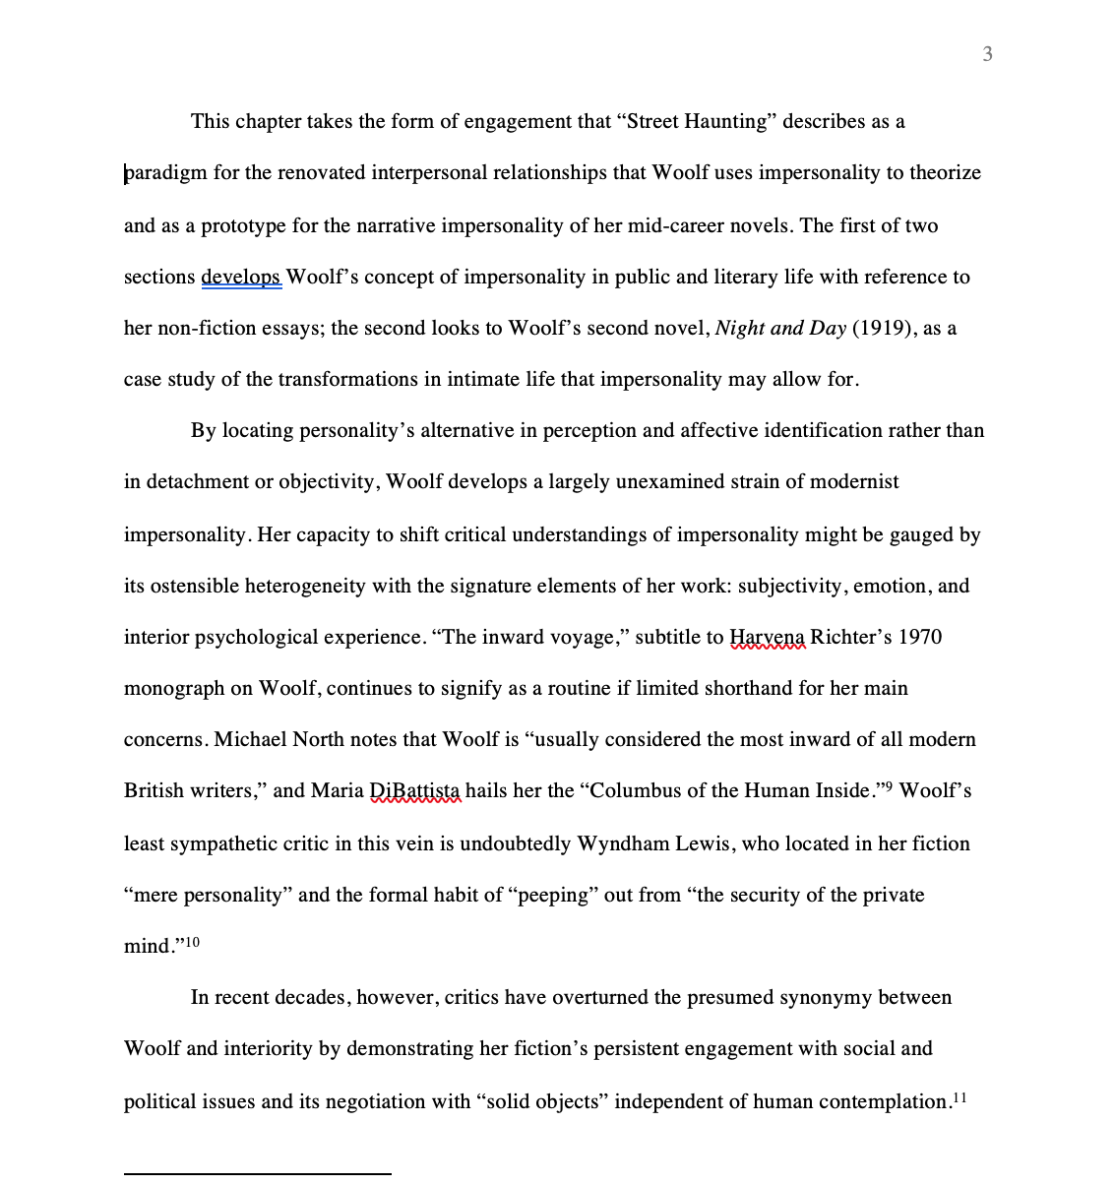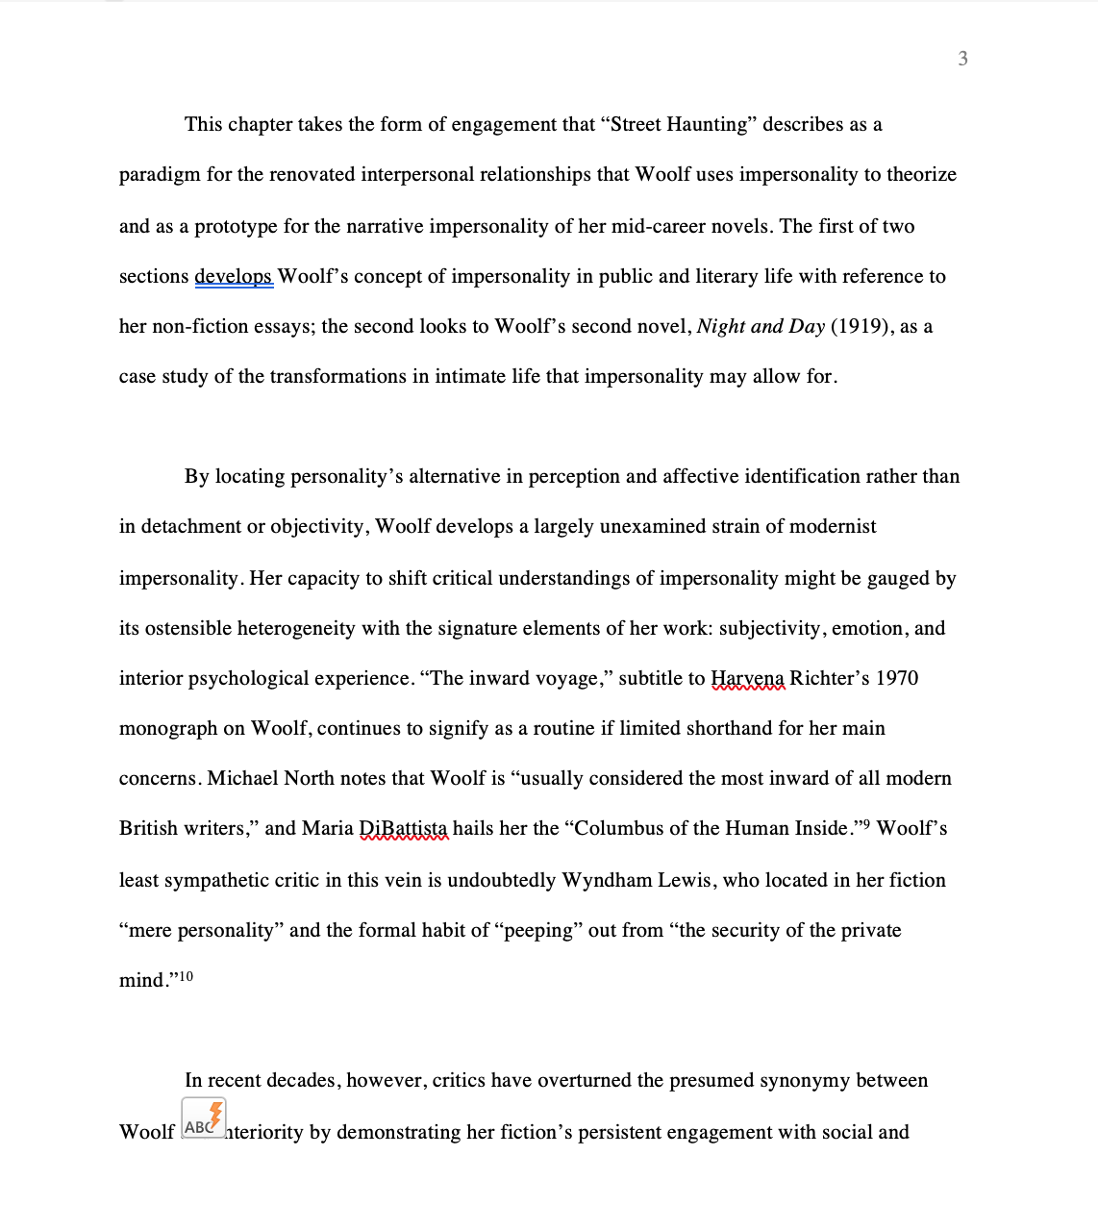

Other basic formatting for humanities papers includes italicizing the titles of novels and putting a poem’s title or short story title in quotation marks. Use MLA or CMS style. See the library reference crew for help.

JB’s Incredibly Useful Crash Course On Cliché and Colloquialism

Words and phrases not to use:

truly
in real life
deeper meaning
at first glance/read
“constantly” as euphemism for “a lot”

Don’t use “feels” unless you are talking about a masseuse. It’s often a cover for a vague thought. If you can’t produce concrete evidence for your claim, let it go.

Ditto “creates an image.” This is too vague and probably subjective: look back to the quote and specify what the connection is between the quotation and what you are claiming is its connotation. If you can’t state it clearly, it’s in your head and not in mine, so start again. For example “heart” can suggest love, a site of success or failure depending on how the cardiac surgeon did, or be connected to light or darkness. There is no inherent meaning in (or to) a heart. Or a rose. Or a color. Or, frankly, anything.

Nothing has “imagery.” Or everything does. This is not useful. Used on its own the word is too ambiguous. What is the image of? If you can’t say, move on. The connection has to be specific.

When You’re Done With Your First Draft (Yes, Draft)

1. Look at your first and last paragraph. Are they related? If not, go back and fix stuff until they are related clearly. Sometimes you figured out what you were writing as you were writing. That’s great, but make sure you do what you say you are doing. Hint: Don’t re-do the body of the paper; rewrite your opening paragraph.

2. Don’t just quote something and move on. Say explicitly what in the quotation is important to your argument and why. You may think it’s clear because it’s clear to you at the minute—and that’s great. Yay. The rest of us are not you, though, so help us out.

3. Don’t end your paper with a generality, a truism, or a wise statement about the world, humanity, life, universe, “42,” etc. You don’t have to prove that a book is an accurate (or inaccurate) reflection of the universe. Actually, you can’t, so relax and enjoy the fact that it’s not your job to explain Life As We Know It and/or justify the existence of literature.

4. Don’t use “the reader.” By “avoid its use” I mean “don’t use it in my class.” The reader is better than “I” but it’s often a cloak for “I.” Expunge subjectivity. Yeah, I know you can’t, but this isn’t a philosophy class, thank god.

5. If you don’t know exactly what a word means, look it up in the OED (Oxford English Dictionary) on the library web site.

6. Don’t put commas in front of your quotations just because it’s a quotation. Work out if it is grammatically called for.

7. Come to office hours and ask a question even if you think it’s basic. If you don’t understand me when I talk, tell me to say it again another way. I talk fast. Tell me to slow down.
Dialogue is vital, and that’s when the best conversations happen in education, and life—which hopefully are not mutually exclusive experiences. Questions are the basis of civilizations.

