Art History 203 (Writing Credit)

Survey of Western Art--Modern

Winter 2022

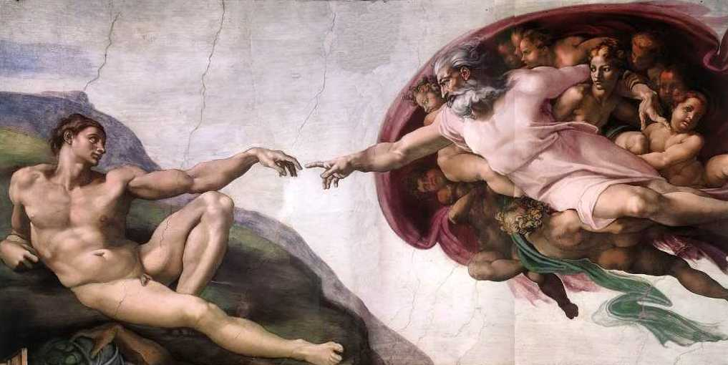
Instructor: Kolya Rice
Office hours: M/W 9-9:50 and by appointment
302 Art krice@uw.edu

Teaching Assistants:
Ananya Sikand: asikand3@uw.edu
Kira Sue: kira2@uw.edu

Course Description:
This course introduces the major figures, styles and movements in Western art from the High Renaissance to the present. It also presents the principle issues, techniques, and interpretive methods of the discipline of art history. As well as learning to recognize the key “monuments” of European and American art from around 1500 to 1900, students will consider how a study of visual products adds to our understanding of past cultures and societies. Illustrated lectures anchor the course, but discussion is always encouraged, and sophisticated reading assignments will be provided to expand upon the text and lectures.

Required Readings:
- Textbook: Marilyn Stokstad, Art History, 6th Edition, vol. 2 (2018) (ISBN-978-0134479262)
Purchase E-text Version
- Electronic Reserve Readings (ER) posted on Canvas
- Lectures Guides (download from Canvas, print, and bring to class)

Helpful sources on 2hr reserve in Art library:
J. Pierce, From Abacus to Zeus: A Handbook of Art History.
J. Hall, Dictionary of Subjects and Symbols in Art.
S. Barnet, A Short Guide to Writing about Art.

“W” Credit Component:

This course has been designated as a “W” or writing intensive course; this is not optional. As such, you may expect substantial writing assignments, writing tutorials, and feedback on your writing over the course of the quarter. An important method to improve writing proficiency is through revision in response to feedback. You are required to revise three writing assignments this quarter. You must complete both the initial assignment and the revision to receive credit for this course. The writing assignments you are required to revise are:
- 3-Page Compare/Contrast Formal Analysis Essay
- 3-Page Summary Essay
- 5-Page Directed Research Paper

Student Responsibilities:
2 quizzes: 10% each (20% of overall grade) see prompt on Canvas
Each quiz will require students to define terms and to write short answers on topics covered in the lectures and readings. These are open notes quizzes—you may return to the lectures and readings when composing your answers. Each quiz will only cover the topics for that 5-week section of the course. In other words, they are not comprehensive. You will have a full week to complete each quiz. These quizzes will be graded on a 10-point scale.

3-Page Compare/Contrast Formal Analysis Essay (10%) See prompt on Canvas
In this writing assignment students will employ a fundamental art historical method of “formal analysis” to see the visual differences between two works of art with similar subjects and to build a compelling written argument that clearly communicates how these visual differences “add up” to different messages. One revision in response to assessment feedback provided during a directed peer review in section will be required. This assignment is graded on a 10-point scale.

3-Page Summary Essay and revision (15%) See prompt on Canvas
In this writing assignment students will be required to clearly summarize important information related to canonical works of art and their cultural contexts that you have encountered in lectures, discussions, and special topic readings over the course of the quarter. One revision in response to assessment feedback will be required. This assignment is graded on a 10-point scale.

5-Page Directed Research paper steps and revision (25%) See prompts on Canvas
In this this research-based writing assignment students will critically assess scholarly arguments in the discipline of Art History, which will provide the basis of a clearly organized and argued interpretation of a work of art. This assignment will have several steps. One revision in response to assessment feedback will be required. This assignment is graded on a 100-point scale.

Active participation in all quiz sections and in-class exercises (30%)
Quiz sections are writing-focused unless otherwise specified. Students will gain skills in college-level art historical rhetoric and composition by workshopping specific fundamentals of academic writing. All students are expected to attend quiz section to contribute to and engage in discussions, group and partner exercises, in-class exercises, and peer reviews. Quiz sections are designed to improve the quality of your course papers and is a necessary component of gaining a “W” credit. Students are required to bring prepared materials to every quiz section unless otherwise noted. See the syllabus for the weekly breakdown of these required materials (RM). Failure to participate in quiz section and to bring required materials will result in a weekly penalty to your participation grade.

Key due dates to remember:
1/16: Initial draft Compare/Contrast Formal Analysis essay due on Canvas
1/21: Final draft Compare/Contrast Formal Analysis essay due on Canvas
1/30: Initial draft Summary Essay due on Canvas
2/4: Annotated bibliography due on Canvas
2/11: Final draft Summary Essay due on Canvas
2/13: Quiz 1 due on Canvas
2/18: Directed Research Paper thesis statement & outline due on Canvas
2/27: Initial draft of Directed Research Paper due on Canvas
3/6: Quiz 2 due on Canvas
3/13: Final draft of Directed Research Paper due on Canvas

Late papers and discussion post policy:
Papers will be marked down 5% for each day they are late and will not be accepted more than five calendar days following the due date. If you have a serious conflict or emergency, please make arrangements with your TA about it in advance of the due date and we will work with you.

Projected Course Outline and Reading Assignments
(Please have these assignments read by the date listed below.)

M 1/3 Introduction to Art History and the course
Stokstad: XVII-XXXVII

T 1/4 Intro to the course (small sections): Key art historical terminology and
“formal analysis”

W 1/5- LG #1: The High Renaissance: Leonardo and Raphael
M 1/10 Stokstad: 645-655
ER: H.W. Janson, History of Art (1995): #58, 59, 61, 66 (all readings
from H.W. Janson in one pdf but are individually numbered).

T 1/11 Formal analysis continued. Compare/Contrast Formal Analysis Essay
prompt discussion

W 1/12 LG #2: Michelangelo
Stokstad: 656-664, 685-689
ER: A. Blunt, “Michelangelo’s Views on Art,” from Readings in Art History II (1983): 103-124.
ER: H.W. Janson, History of Art (1995): #60, 62, 63, 64, 65, 67.

M 1/17 No Class Meeting: MLK Holiday
T 1/18 Peer review of Compare/Contrast Formal Analysis essay.
RM: Bring a hard copy of your essay to section

W 1/19 LG #3: Northern Italian Renaissance painting
Stokstad: 668-673
ER: J. Berger, Chapter 3 from Ways of Seeing (1972): 45-64.

M 1/24 LG #4: Mannerisms, 16th Century Venetian and Spanish painting
Stokstad: 673-675, 678-684, 709-710 (El Greco).
ER: H.W. Janson, History of Art (1995): #68.

T 1/25 Summary Essay Prompt and discussion. Intro to Directed Term Paper and
discussion

W 1/26- LG #5 and #6: The Northern Renaissance
M 1/31 Stokstad: 691-702, 711-719
ER: H.W. Janson, History of Art (1995): #70, 71.
Optional ER: B. Scribner, “Ways of Seeing in the Age of Dürer,” from
Dürer and His Culture (1998): 93-117, 221-24.

**T 2/1 Directed Research Paper workshop: Prompt for Thesis/Outline and
discussion

W 2/2 LG #7: Italian Baroque painting and sculpture
Stokstad: 725-741 (skim sections on architecture).
ER: H.W. Janson, History of Art (1995): #72.

M 2/7 LG #8: Baroque painting in France and Spain
Stokstad: 742-748, 769-778
ER: H.W. Janson, History of Art (1995): #76.

T 2/8 Quiz #1 review. Summary Essay initial feedback and peer review.
RM: Bring a hard copy of your Summary Essay to section.

W 2/9 LG #9: Baroque painting in Flanders and Holland
Stokstad: 749-768
ER: D. Mitchell, “Rembrandt’s The Anatomy Lesson of Dr. Tulp: a Sinner among the Righteous,” Artibus et Historiae (1994): 145-156.

M 2/14 LG #10: Rococo Painting

Stokstad: 922-929

T 2/15 Directed research Paper workshop: Thesis and Outline
RM: Bring a hard copy of your thesis and outline to section.

W 2/16 LG #11: “The Grand Manner” in the U.S. and England
Stokstad: 929-945
ER: H.W. Janson, History of Art (1995): #81.

M 2/21 No Class Meeting: President’s Day Holiday

T 2/22 Directed Research Paper workshop: Initial feedback and common
mistakes
RM: Bring a hard copy of the 1st draft of your Directed Research Paper to
section.

W 2/23 LG #12: 19thC Representations of Native Americans and the West
Stokstad: None
ER: R. Hughes, excerpt from American Visions: The Epic History of Art in America (1997): 175-205.

M 2/28 LG #13: Neoclassicism and Romanticism in France and Italy
Stokstad: 952-956
ER: Eugène Delacroix, excerpts from his Journals (1822-24 & 32) from
Art in Theory: 1815-1900 (1998): 26-30 & 84-89.

T 3/1 Directed Research Essay workshop

W 3/2 LG #14: Romanticism in England, Germany, and Spain
Stokstad: 956-974

M 3/7 LG #15: 19thC French Academicism, Naturalism and Realism
Stokstad: 980-993
ER: L. Nochlin, “Women Art and Power,” from Women Art and Power
and Other Essays (1988): 1-36.

T 3/8 Directed Research Essay workshop. Review for Quiz #2

W 3/9 LG #16: Manet and Impressionism
Stokstad: 993-1010

VeriCite anti-plagiarism software:
Notice: The University has a license agreement with VeriCite, an educational tool that helps prevent or identify plagiarism from Internet resources and work submitted by previous students of this course. I will use the service in this class; all assignments and quizzes you submit will be checked by VeriCite. The VeriCite Report will indicate the amount of original text in your work and whether all material that you quoted, paraphrased, summarized, or used from another source is appropriately referenced. All instances of intentional plagiarism will result in zero credit on the assignment, and a report of indicating academic dishonesty to the School of Art and the University of Washington. For further information, visit: https://itconnect.uw.edu/learn/tools/canvas/canvas-help-for-instructors/assignments-grading/vericite/plagiarism-faqs/

