Glits 252 C/Slavic 200 A/C Lit 252 C: Introduction to World Poetry
Spring 2024, M/W 12:30-2:20

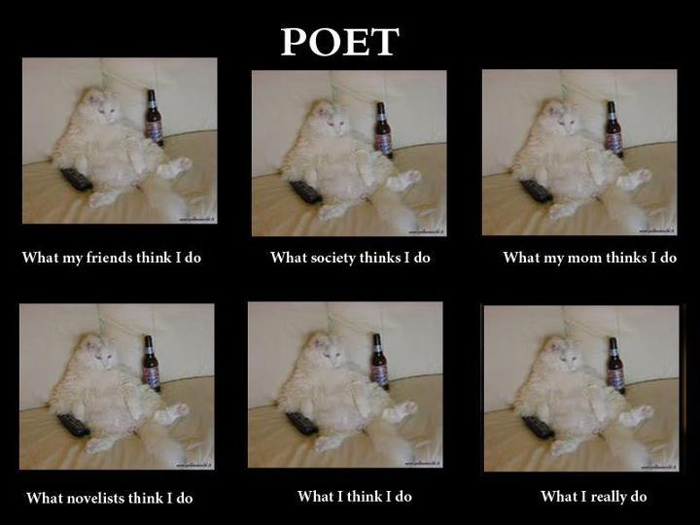

Instructor: Piotr Florczyk, PhD (piotrf@uw.edu)
Teaching Assistant: Anna Learn (learna@uw.edu)
Prof. Florczyk’s Office Hours: W, 11:00am-12:15pm (and by appointment)
Anna Learn’s Office Hours: Th, 10:00am-12:00pm
(online: https://washington.zoom.us/j/94151136798)

“What is poetry which does not save / Nations or people? / A connivance with official lies, / A song of drunkards whose throats will be cut in a moment, / Readings for sophomore girls. / That I wanted good poetry without knowing it, / That I discovered, late, its salutary aim, / In this and only this I find salvation.”
—from “Dedication” by Czesław Miłosz, trans. by the author and Robert Hass

Course Description:

This quarter we will immerse ourselves in the reading of poems in order to learn how poems are made and received. In addition to focusing on close-reading and insightful analysis of poetry sampled from around the world—as well as issues pertaining to translation and cross-cultural dialogue—we will also investigate various social, political, and cultural contexts and themes, such as war, death, feminism, and nationhood, to see if and how they might have impacted the authors under discussion. Furthermore, students will also have opportunities to hear guest speakers and to write their own original poems, with the idea that hands-on learning gives us a higher appreciation for the subject under discussion. Our goal will be to experience the creative and critical processes together, so that our communal experience is not just an addendum to act of reading and discussing poetry, but an extension of it. All readings in English. No prerequisites.
TRIGGER WARNING: As the poet Lucille Clifton once said in an interview, “You cannot play for safety and make art.” As you know, poetry often confronts very complex issues. Please be aware that you should SKIP any poem and step away from any discussion as needed this term, no questions asked. I can’t always give the TW in advance as it’s impossible to know what might trigger someone, but I will try to give a general sense of what’s coming on these issues.
Required Texts and Materials (eBook or paper copies):

- The Ecco Anthology of International Poetry, eds. Kaminsky and Harris. Ecco, 2010 (ISBN: 978-0061583247)
- Handouts: The Ecco text provides an excellent selection of classic and modern poets from around the world, but we will also read poets whose work isn’t included, such as contemporary American authors Solmaz Sharif, Ocean Vuong, or Ahmad Almallah.

Learning Objectives:

The aim of this class is to offer all participants the intellectual and creative guidance to help them enjoy poetry, develop their own creative texts as well as the necessary techniques for participation in the ongoing dialogue with other writers and critics; more specifically:

- The ability to articulate a craft-based analysis of poems;
- The ability to put theory to practice by completing creative writing exercises;
- The ability to describe and define the conventions, contexts, expectations of various poetic schools and traditions;
- Application of critical thinking and reading skills to written analysis of literary works and texts.

Assignments and Grading:

- Two response papers (500-600 words), 60%
- Presentation (10 minutes), 20%
- Active class participation, including in-class poetry writing, 20%

Response papers: Choose a poem (covered in class) and in a paper of 500-600 words please reflect on its form and content, as well as any pertinent biographical/historical/political, etc. contexts, as if you were introducing it to a stranger.

Group presentation: The poets and the poems under discussion in our class are not the only voices worthy of our attention, and this is where you come in. In a group of 2 (or solo), please introduce us to a poet whose work has not been covered in class. Your poet may come from the U.S. or another country, write in English or another language. Conversely: Write and read a poem of ~30 lines (free verse or closed from; on any subject. Make sure your poem has a title. Solo authorship only).

In-class poetry writing: We will begin some of our meetings with a poetry-writing prompt based on the session’s readings. These creative writing exercises are meant to help the students sharpen their own poetic and self-expression skills.
Tentative Class Schedule:

Week 1:
M 3/25 Introduction
W 3/27 Poetry of North America [Handout: Elizabeth Bishop, Kim Addonizio, Charles Simic, Ocean Vuong, Franny Choi, Terrance Hayes]

Week 2:
M 4/1 Poetry of North America [Ecco: Octavio Paz, Claribel Alegría, Ernesto Cardenal, Aimé Césaire, Rubén Darío, María Elena Cruz Varela]
W 4/3 Guest Speaker: Prof. Jean Boase-Beier

Week 3:
M 4/8 Poetry of Asia [Ecco: Bei Dao, Duoduo, Ge Cheng, Faiz Ahmed Faiz, Nâzim Hikmet; [Ecco: Kim Nam-Jo, Ko Un, Lei Shuyan, Sadanand Rege, Zahrad]
Extra Credit Opportunity! A reading by Prof. Jerzy Jarniewicz, 6-7:30pm

W 4/10 Lecture TBD
Writing due: Response Paper #1

Week 4:
M 4/15 Poetry of Africa [Ecco: Bernard Dadié, Patrice Kayo, Augustinho Neto, Léopold Sédar Senghor]
W 4/17 Poetry of Africa [Handout: Antjie Krog, Kofi Awoonor, Christopher Okigbo, Breyten Breytenbach]

Week 5:
M 4/22 Poetry of South America [Ecco: Carlos Drummond de Andrade, Jorge Luis Borges, Oscar Hahn, Gabriela Mistral, Pablo Neruda, Adélia Prado]
W 4/24 Guest Speaker: Prof. Boris Dralyuk

Week 6:
M 4/29 TA Research Lecture
W 5/1 Poetry of the Near East [Ecco: Yehuda Amichai, Mahmoud Darwish, Vénus Khoury-Ghata, Salah Niazi]
Writing due: Response Paper #2

Week 7:
M 5/6 Poetry of the Near East [Ecco: Dunya Mikhail, Taha Muhammad Ali, Amjad Nasser, Mansur Rahjih]
W 5/8 Film

Week 8:
M 5/13 Poetry of Europe [Handout: Czesław Miłosz, Zbigniew Herbert, Tadeusz Różewicz, Wisława Szymborska, Uljana Wolf, Douglas Dunn, Paul Celan, Ingeborg Bachmann, Michael Hofmann, Ciaran Carson, Paul Muldoon, Eavan Boland]
W 5/15 Guess Speaker: Prof. Krzysztof Hoffmann

Week 9:
M 5/20 Group Presentations
W 5/22 Group Presentations

Week 10:
M 5/27 No Class: Memorial Day
W 5/29 Group Presentations

Bibliography for Further Study: Please see me

OTHER MATTERS OF IMPORTANCE

ACADEMIC INTEGRITY
The University takes academic integrity very seriously. Behaving with integrity is part of our responsibility to our shared learning community. If you’re uncertain about if something is academic misconduct, ask me. I am willing to discuss questions you might have.
Acts of academic misconduct may include but are not limited to:
- Cheating (working collaboratively on quizzes/exams and discussion submissions, sharing answers and previewing quizzes/exams)
- Plagiarism (representing the work of others as your own without giving appropriate credit to the original author(s))
- Unauthorized collaboration (working with each other on assignments)
Concerns about these or other behaviors prohibited by the Student Conduct Code may be referred for investigation and adjudication.
Students found to have engaged in academic misconduct may receive a zero on the assignment, or face other possible outcomes.
RELIGIOUS ACCOMODATIONS
Washington state law requires that UW develop a policy for accommodation of student absences or significant hardship due to reasons of faith or conscience, or for organized religious activities. The UW’s policy, including more information about how to request an accommodation, is available at https://registrar.washington.edu/staffandfaculty/religious-accommodations-policy/. Accommodations must be requested within the first two weeks of this course using the form at https://registrar.washington.edu/students/religious-accommodations-request/.

DISABILITY RESOURCES
Your experience in this class is important to me. If you have already established accommodations with Disability Resources for Students (DRS), please communicate your approved accommodations to me at your earliest convenience so we can discuss your needs in this course. If you have not yet established services through DRS, but have a temporary health condition or permanent disability that requires accommodations (conditions include but not limited to; mental health, attention-related, learning, vision, hearing, physical or health impacts), you are welcome to contact DRS at 206-543-8924 or uwdrs@uw.edu or disability.uw.edu. DRS offers resources and coordinates reasonable accommodations for students with disabilities and/or temporary health conditions. Reasonable accommodations are established through an interactive process between you, your instructor(s) and DRS. It is the policy and practice of the University of Washington to create inclusive and accessible learning environments consistent with federal and state law.

RESPECT
We aspire to create a classroom environment that encourages and welcomes different perspectives. How do we learn anything in the absence of robust engagement with ideas and views that differ from our own? Respect for different views and the people who express them does not necessarily mean agreement with them; at a minimum, it means that we should cultivate gratitude for the opportunity to re-examine our habits of thought. Let’s work together and show mutual respect.

*****
For more information on disability accommodations, academic integrity, safety, and religious accommodations, please see https://registrar.washington.edu/staffandfaculty/syllabus-guidelines/

