Antoine Nauleau
English 131
Leah F. Rankin
10/30/12

Short Assignment 2.1—Analysis of a Static Advertisement
Static advertisements, anchored by slogans and captions, have been used by people for many years to share their product or idea. This static advertisement is for the Oscar nomination of the film “Batman: The Dark Knight”. This film was rated PG-13 and was presented for the more mature audience of adolescents all the way to adults. The image is of the character named The Joker, who accordingly, is holding the card of a joker. He has an evil look to him, and seems very concentrated on something in the distance. Besides him, there is a slogan that says “We Showed You How To Go Mad”. This is promoting that the movie had shown the viewer how to go mad or crazy, creating a sense of companionship between the viewer and the advertisement. With the slightly hidden “Oscar.com”, the idea becomes clear that the advertisement is asking the viewer to support the movie in its Oscar nomination. On the bottom there is a caption that is a part of the Oscar Nomination company. All of this comes together to create an advertisement that can be further analyses by taking a look at the three messages that Roland Barthes developed in his “Rhetoric of the Image”, which are the linguistic, symbolic, and literal messages. These three messages and their interaction with each other is what constitute this advertisement, and if one of these is removed or altered, the image would not be the same.
The linguistic message in this advertisement is split into three different captions. The first one is “We Showed You How To Go Mad”. Research of this advertisement on the same website that it was located it on, reveals that the Oscar nominations for every film, all feature the words “We Showed You”. Different films’ themes were them summarized and another slogan was added after this that describes the film and makes the slogan come together in each film’s unique way. In this case the “How To Go Mad” relays to the movie “Batman: The Dark Knight” and the character of the movie named The Joker, who is being portrayed as being a crazy paranoid schizophrenic in this advertisement. This is the connoted message, as it expresses the “mad” aspect of the image. The next two linguistic messages are the “Oscar.com” and the “There’s A Little Bit Of The Movies In All Of Us” which is the denoted message. It is just the slogan of the Oscar Company and was on all of the other advertisements for the other movies. These three different captions work together to anchor the image to what the advertisement is actually trying to portray.
There are a few symbolic messages in this advertisement, which are identifying the non-linguistic and non-literal part of the image. The first thing that comes to the eye of the viewer is that the person in this image is crazy and evokes an evil feeling. This is supported by his melted make-up and dirty hair, as well as his distant and twisted look. Make-up worn in this fashion resembles a clown or a joker, and the dirty un-kept hair is symbolic of a person who is crazy and does not take care of their hygiene anymore. The look in the eye of this character is symbolic of the non–empathetic soul of a psychopath. He is also wearing a suit which is ironic as this character is dirty and crazy looking, which contrasts with the clean-cut look that a suit usually offers. The character himself is also simply a character, which is being played by an actor. All of these symbolic messages come together to give a persuasive feeling which is that the movie was scary and that this character is crazy.
The literal messages in this static advertisement are the direct meaning and the actual idea of the advertisement. These are quite clear, such as the card being held is a card, the hand holding the card is covered with a glove, and that the person is wearing a suit. Taking a step back from the details reveals that the character in the image is in fact the character named The Joker. His distinct features such as the eye shadow, lipstick, and scared lips reinforce that this is indeed him. Furthermore the character is holding a card of a joker. This is a signature move of The Joker and reinforces the viewer’s thought even more into supporting that this character is in fact The Joker from the movie. On the bottom left corner there is the Oscar symbol. The relationship of this symbol and the image of this character displays that the actor of this character in this movie is being nominated for an Oscar award. Information found on the website that this advertisement is being shown on, reinforces that this is accurate. Without the relationship of the literal messages of the character and the Oscar symbol, this advertisement would not be able to portray its true meaning.
The linguistic, symbolic, and literal messages work together in a unique way that their relationship is what constitutes this advertisement. With one of these key elements missing, the advertisement would not be complete or make sense in the way that it does now. Each message in the image impacts each other in such a way that it creates this advertisement. The persuasive feeling the symbolic message gives, reinforces the “evil” or “mad” that this advertisement is trying to utilize. The linguistic message then anchors this evil feeling by combining it’s saying with the evil symbols. All of this comes together to reveal the literal message that the actor of this evil character is being nominated for an Oscar due to his outstanding performance as the character called the Joker. All these of these parts are crucial in the structure of the advertisement and without one it changes the entire meaning of the advertisement.

Work Cited
Chris, “Heath Ledger’s ‘The Dark Knight’ Joker featured in Oscars ad”, 02/09/12, 10/29/12 <http://batman-news.com/2012/02/09/heath-ledgers-joker-the-dark-knight-featured-in-oscars-ad/>
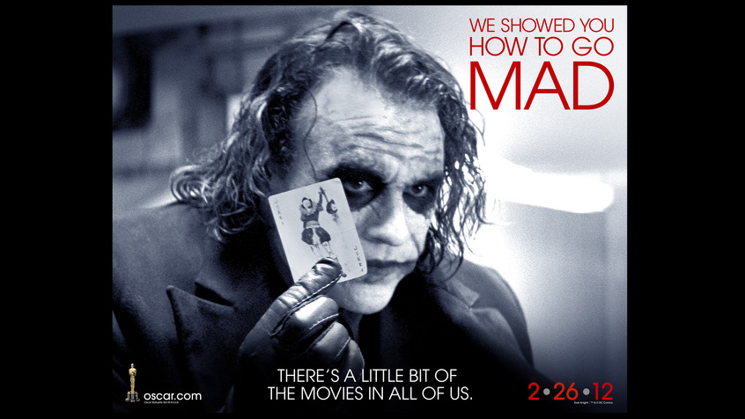
Short Assignment 2.1 Rubric
See the course syllabus for a discussion of each evaluation category.
 | Outstanding | Strong | Good | Acceptable | Inadequate
Introduction: Begins with a concise paragraph that is effective at introducing the advertisement and situating the claim. |  | X
Claim: The paper exhibits a claim that is clearly articulated and appropriately complex. | X
Analysis: The essay addresses how multiple parts of the advertisement work together to create a persuasive argument. This includes investigating what makes the argument persuasive as well as considering the rationale behind the rhetorical choices the author has made in synthesizing different forms of messages. |  |  |  | X
Organization: The paper is organized in an effective manner that highlights the overall goals of the essay. |  | X
Tone: Written in a manner appropriate for a scholarly audience. The presumption of knowledge is an inquisitive reader with experience in observing (although not necessarily analyzing) modern American culture. |  |  | X
Format: The paper is of the required length and follows the prescribed formatting guidelines as outlined in the course syllabus. | X

