Joonkyung Lee (Lena)
English 111
Short Paper 1.2
Margaret Atwood’s famous novel, The Handmaid’s Tale, is a post-modern dystopian text that explores the issues of feminism. Through the novel, Atwood tries to answer the question: “who are the true enemies of feminism?” Susan Faludi also addresses the same question in her book, Backlash: The Undeclared War Against American Women. By putting these two books in conversation with each other, we should be able to acknowledge that it is not simply one factor that has blocked women from achieving equality. Active antifeminists, men, and media have formed a complex interworking system to fight against feminism.
Serena Joy
It seems like her existence itself could be a backlash on feminism. She used to be an active antifeminist-you might already notice how the words ‘active’ and ‘antifeminist’ are contradictory to each other-who claimed that women should stay home when she was out in public giving speeches. She takes in a quality of feminists, voicing her opinions, and twists that quality in order to deliver the antifeminist ideas.
Offred
Dante said “The darkest places in hell are reserved for those who maintain their neutrality in times of moral crisis.” If Dante was true, Offred definitely booked a ticket that will take her straight to the darkest spot in hell. She was indifferent and coward towards the women's equality issues. Her mother even told her that Offred was so ignorant about feminism and took her freedom for granted. Also, even though she was actually frightened by Serena Joy’s appearance on TV, she pretended to just laugh off because her husband thought it was funny. Bystanders like Offred pretend not to be aware of the injustice happening around them when in fact they are. They are worse because they believe that they are innocent since they do not show any means of involvement.
I can go on and on pointing out all the mistakes that we, women, have made in our journey to achieving women’s equality. However, I am hesitant to solely blame ourselves for becoming our own oppressors. It is obvious that we have not been benefiting from oppressing our own peers. Many women are still suffering from inequality economically, politically and domestically. Then, who are profiting from this? I have a feeling that those who are taking advantage of this women vs. women phenomena are the one who led women to fight against each other. Women have been like Marionettes controlled by puppeteers that are hidden behind a bar. Susan Faludi in her book Backlash gives us ideas who these hidden puppeteers are.
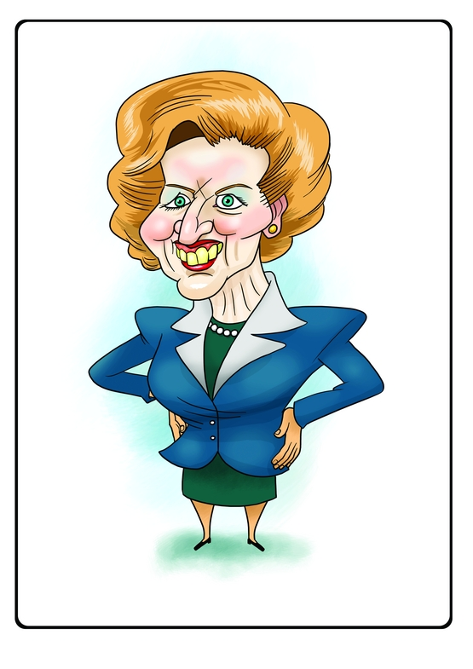
The Republican Women Against Women
Faludi explains how conservative male politicians create women like Serena Joy. They use their female comrades “to rein in women’s political advances” (Faludi, xiii). Newt Gingrich gave the lead slot and the top seven posts in the National Republican Congressional Committee to the female conservative politicians. These female conservatives, backed up by their male comrades, went out into public with their perfectly sprayed hair and pearl necklaces around their necks and talked all they wanted about opposing abortion rights, women staying home protected by their men, etc. Another contradictory antifeminist that Atwood creates in her novel is Aunt Lydia. When Serena Joy has done her job and is forced to stay home under Gilead’s regime, men replace Serena Joy with Aunt Lydia and put her in charge of indoctrinating the Handmaids with the beliefs of the new society and making them accept their fates. For example, she teaches the Handmaids that they should be thankful that they don’t have to worry about getting raped or not being able to find a husband to get married because they are now highly protected by the system. And she teaches them that having such protection/security is more valuable than having equal rights as men. Since the instructions that Aunt Lydia implants in Offred are so powerful, they still haunt Offred in her daily life even after she leaves the Red Center. While these contradictory antifeminists such as Serena Joy and Aunt Lydia are babbling about how women should live, the male conservative politicians, the true puppeteers, are hidden behind, so they can kill two birds with one stone; they can promote the antifeminism ideas through their puppets and direct the criticism bullets shot by feminists to their puppets. Therefore, feminists would end up fighting against anti-feminists women who are not the true core enemy here.
Media/ Pop Culture
Those sly chauvinist pigs are not the only distraction for women in crossing the finish line of the women’s equality marathon. Media also plays a big role. Media delivers wrong information about today’s feminism and this can cause women to become indifferent-like Offred-about this matter. Films, TV shows and magazines keep telling us that the women’s movement is women’s own worst enemy. They force women to falsely believe that the women’s movement is the cause of women’s unhappiness and predicament. For example, Faludi explains how the single/unwed women in Hollywood films are usually portrayed as desperate, humiliated and remorseful. The Commander also has a similar idea. He said that under Gilead's regime, all women "get a man, nobody's left out...this way they're protected, they can fulfill their biological destinies in peace" (Atwood 219-220). He claims that by taking away women’s freedom, they have made women’s lives “easier” because women now don’t have to worry about going through all the hoops and hurdles to get chosen by men. These false images of the single women implant negative notion of feminism in our minds. If we were told that depression, infertility, unhappiness are all we get after fighting for our own freedom, it would be very hard for us to continue our journey. A lot of us will tend to become indifferent. Indifferent, not oblivious. They are aware of the problems that women still face, but they don’t want to fight anymore in this hopeless battle. Instead, they pretend not to acknowledge the problems and surrender.
Keep Your Friends Close and Your Enemies Closer
There is a famous saying that you have to keep your friends close and your enemies closer. In the case of fighting for women’s equality, we should keep our friends closer, so we know what kind of problems our fellow women are going through in their lives. This way, we clearly know what we are fighting for. For the latter part of the saying, it is a little trickier because we first have to figure out who our true enemies are before keeping them closer. After we correctly identify our true enemies, then we will have to keep them closer and come up with effective strategies to fight against them and win our equality.
Susan Faludi’s book, Backlash: The Undeclared War Against American Women, provides scientific facts and statistics to define who the true enemies are. Margaret Atwood’ novel, The Handmaid’s Tale, then goes a step further and shows us how those enemies can bring psychological and interpersonal effects to women by taking away women’s freedom. These two texts together offer us a better explanation of the complex nature of the feminists’ true enemies and their effects of gender oppression on women.

Works Cited
Atwood, Margaret. The Handmaid's Tale. Boston: Houghton Mifflin, 1986. Print.
Faludi, Susan. Backlash: The Undeclared War against American Women. New York: Crown, 1991. Print.

